学习指南：

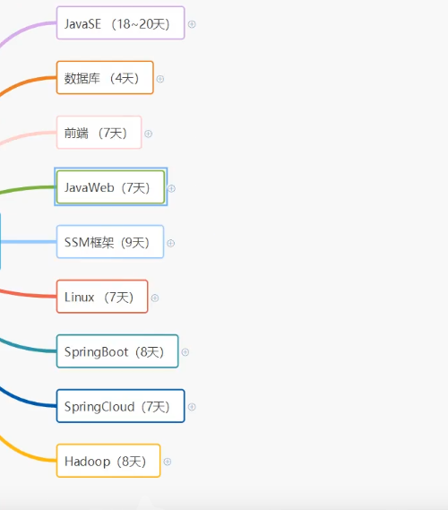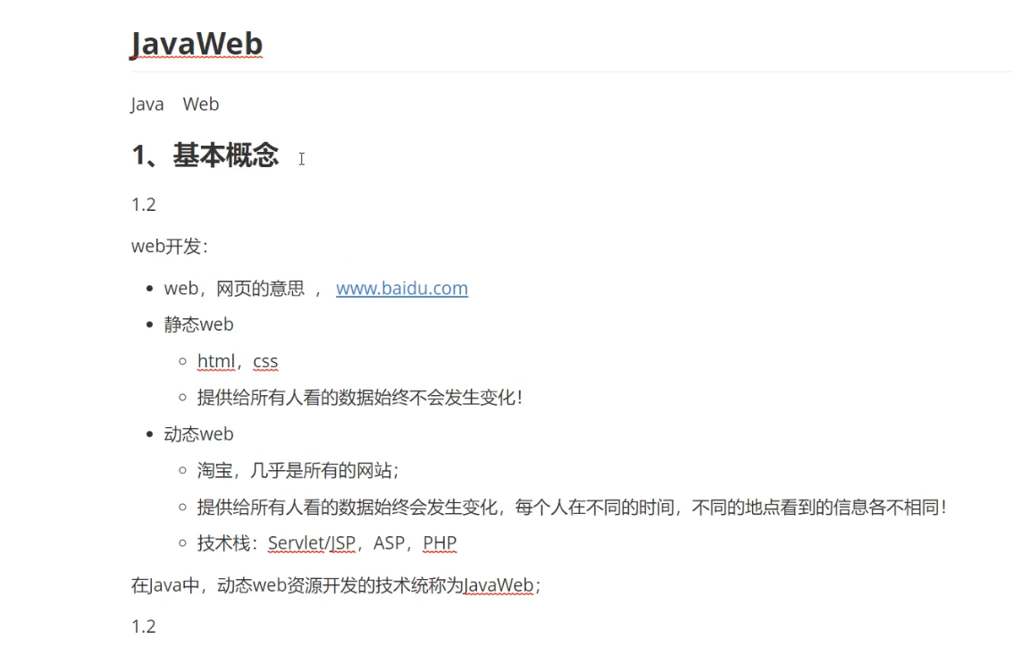

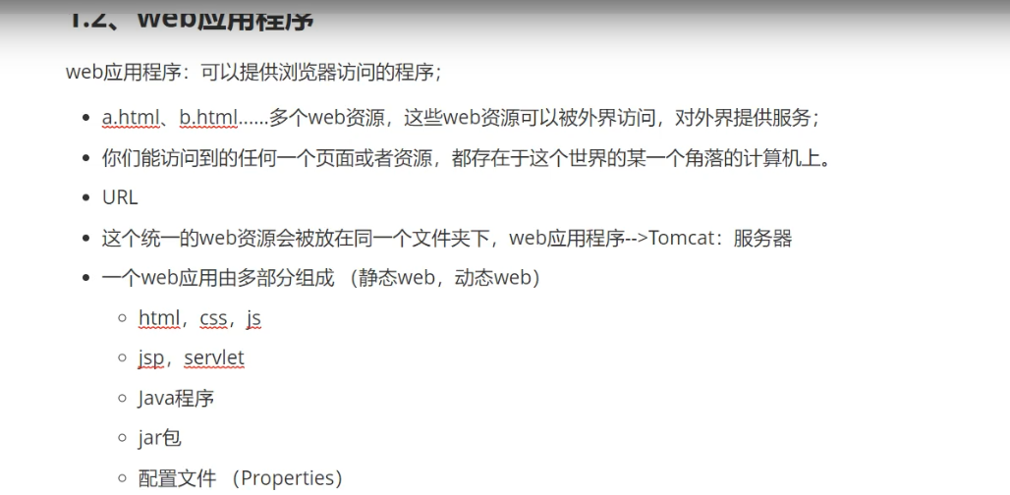



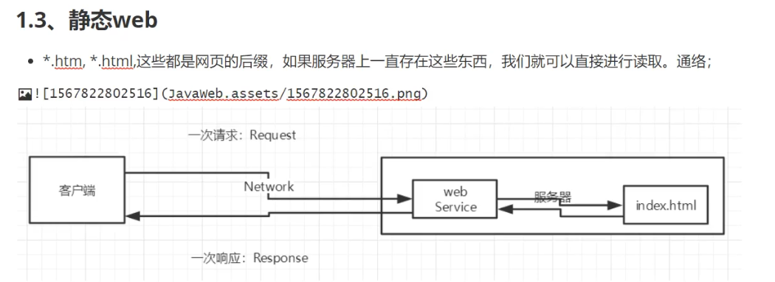

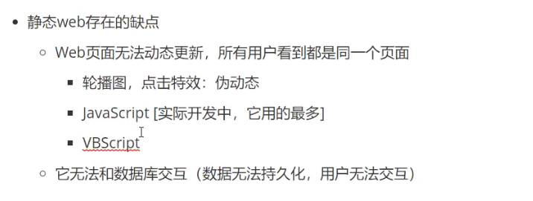

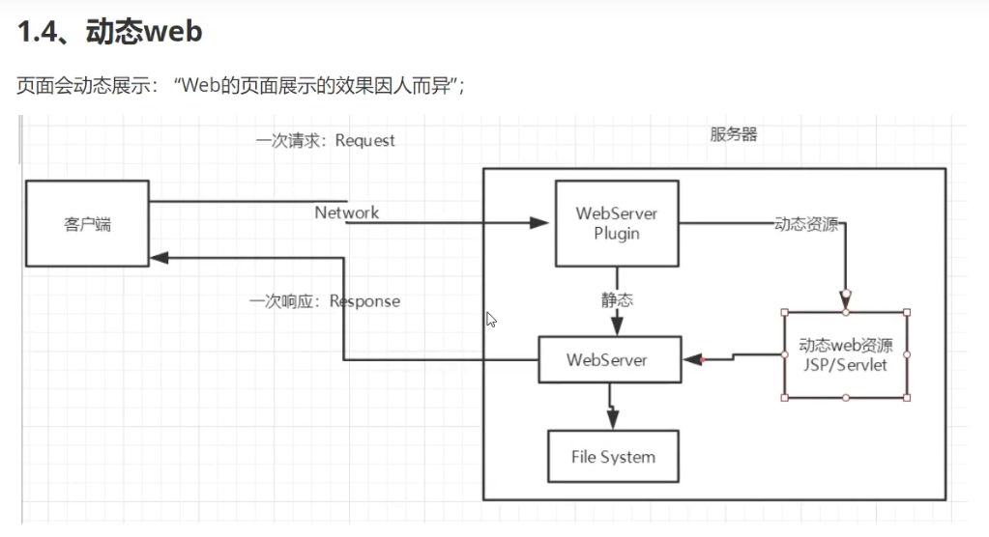

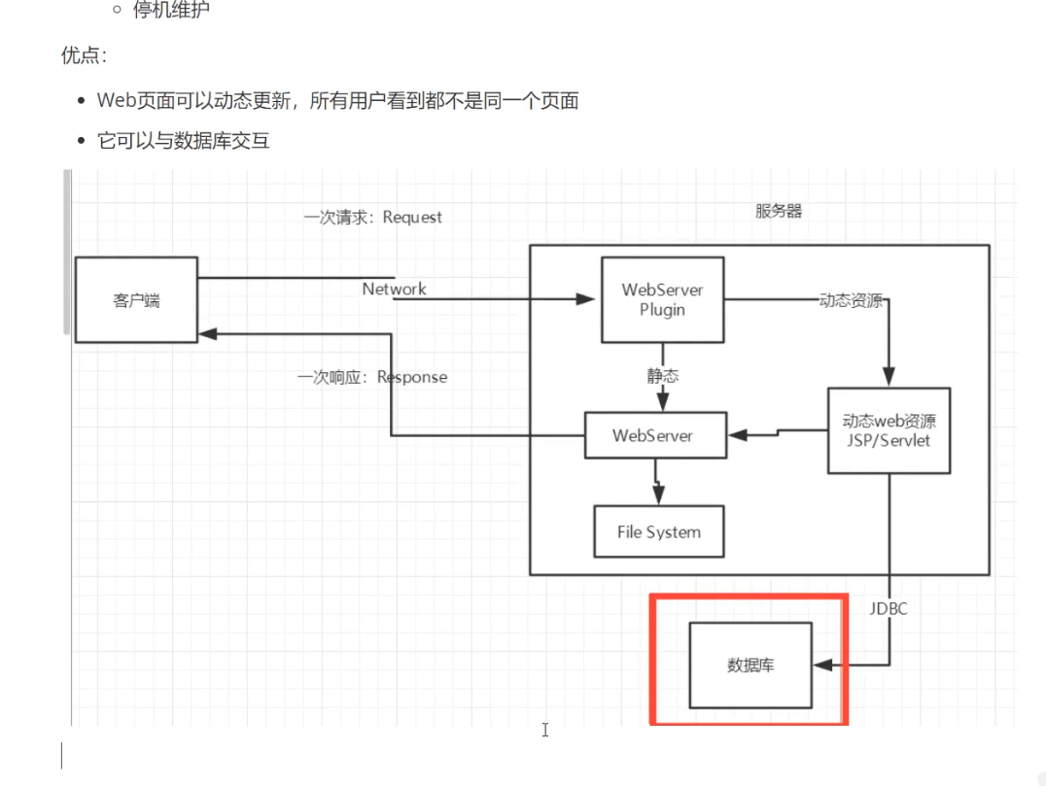

3.

D:\eclipse ee\apache-tomcat-9.0.41\apache-tomcat-9.0.41\bin

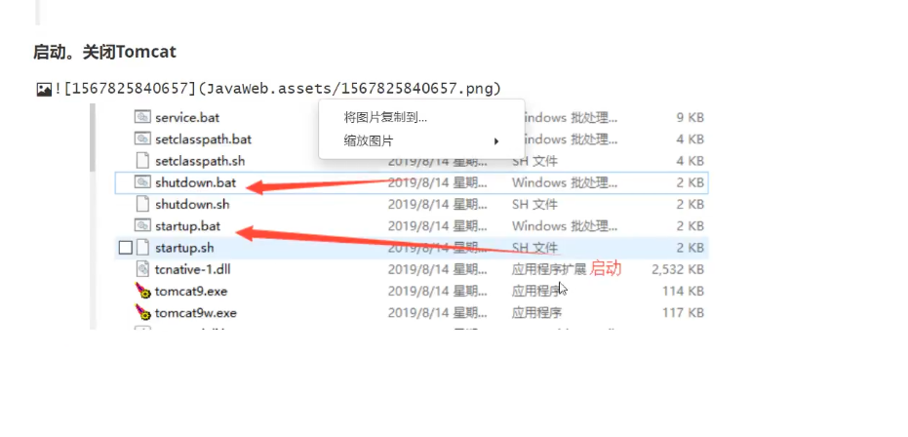



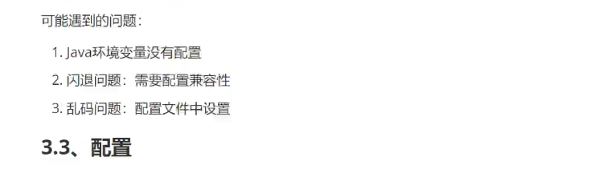

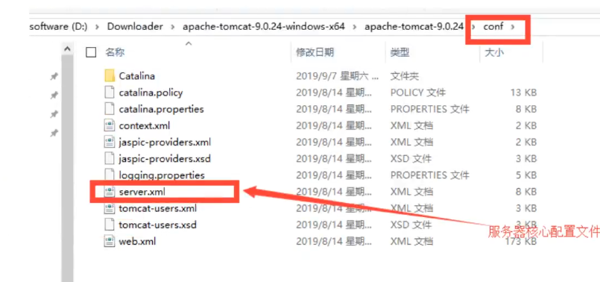

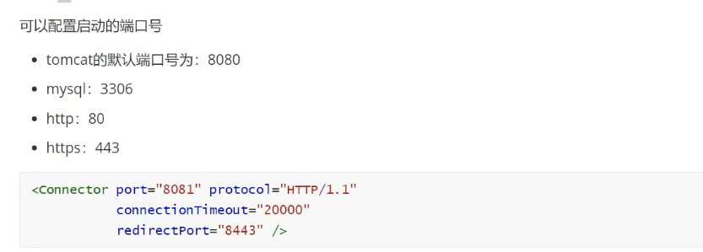

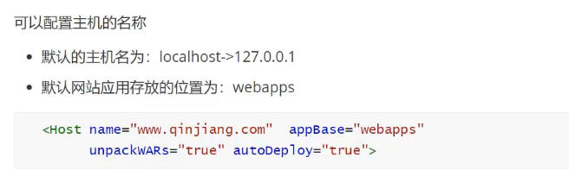

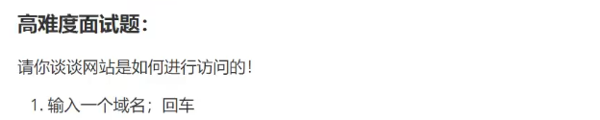

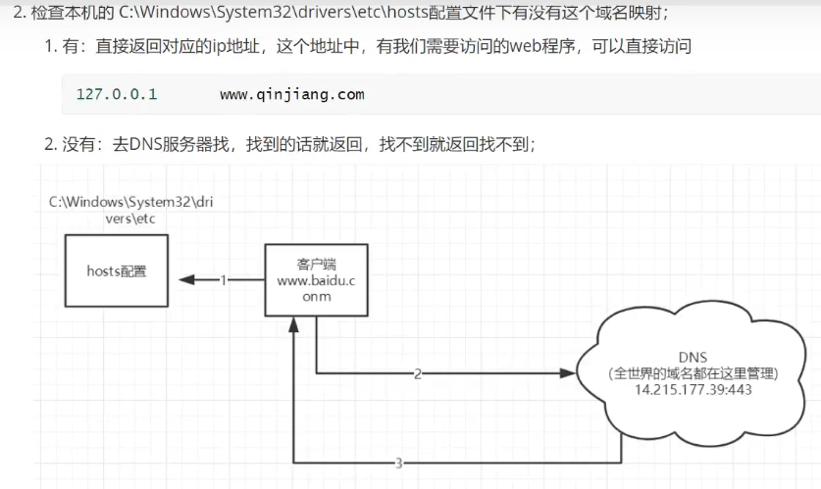

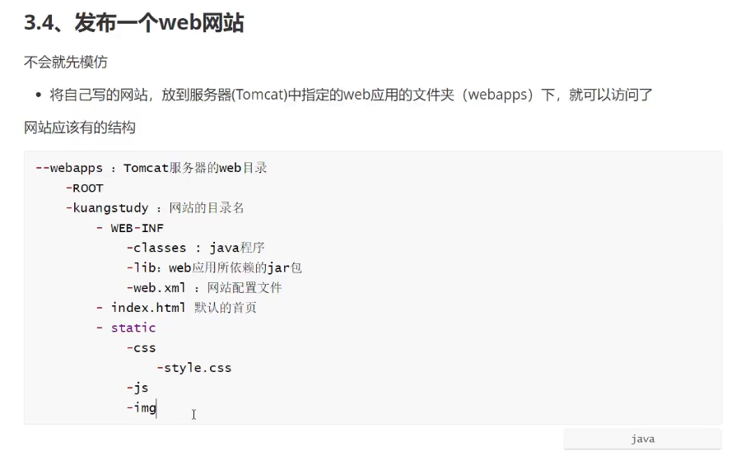

4.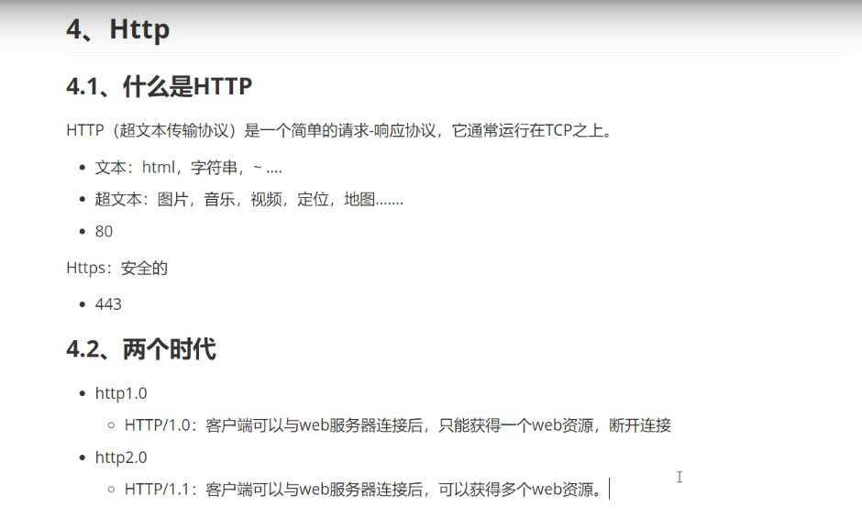

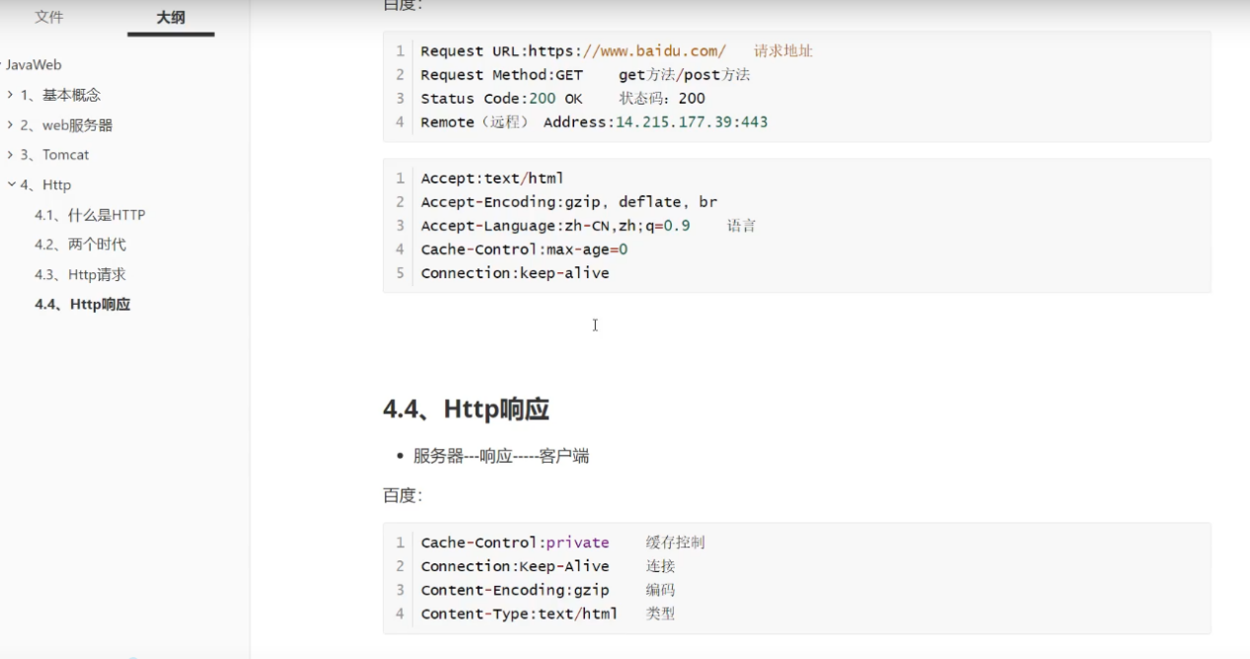

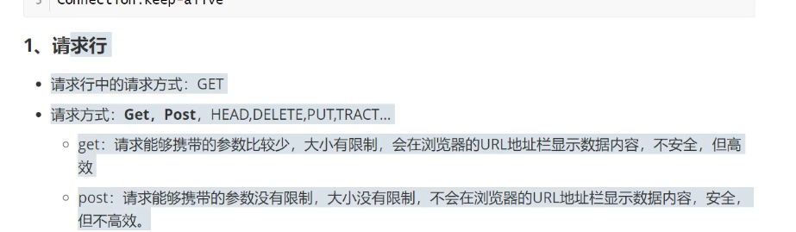

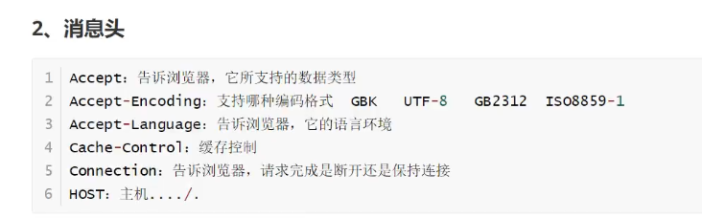

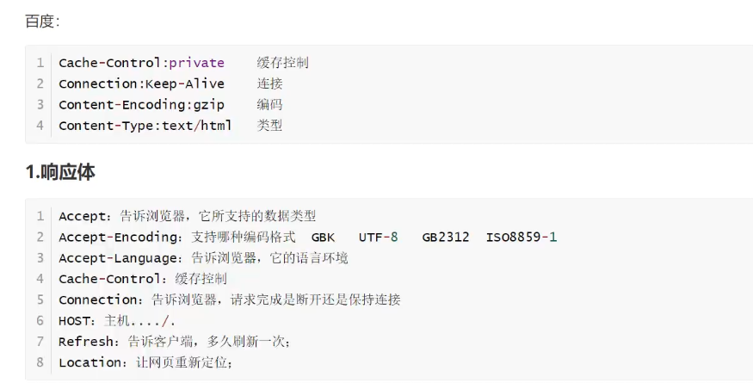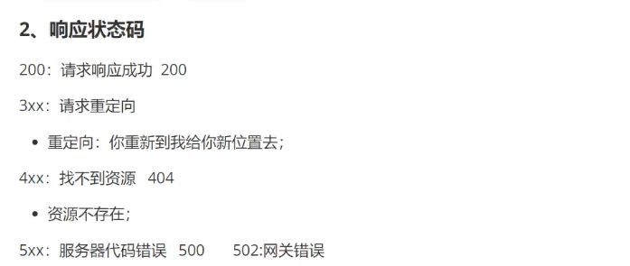

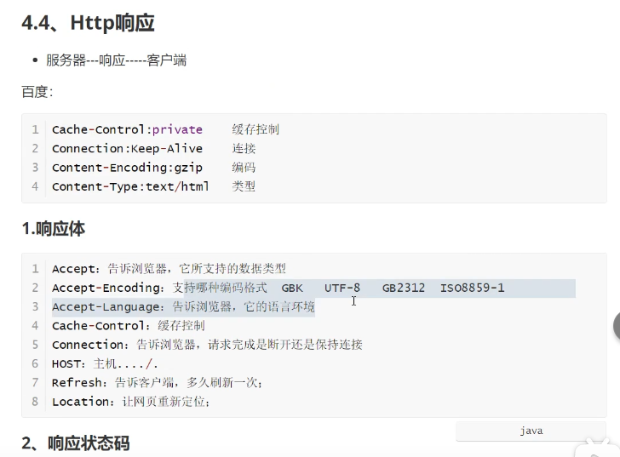

5.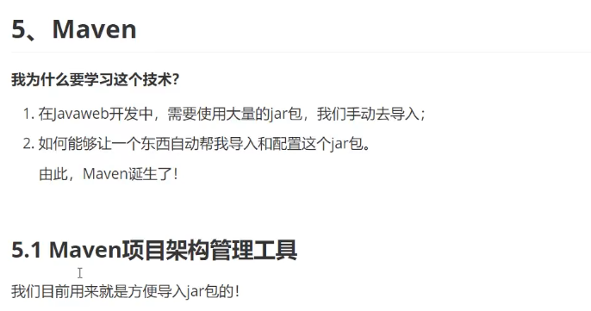

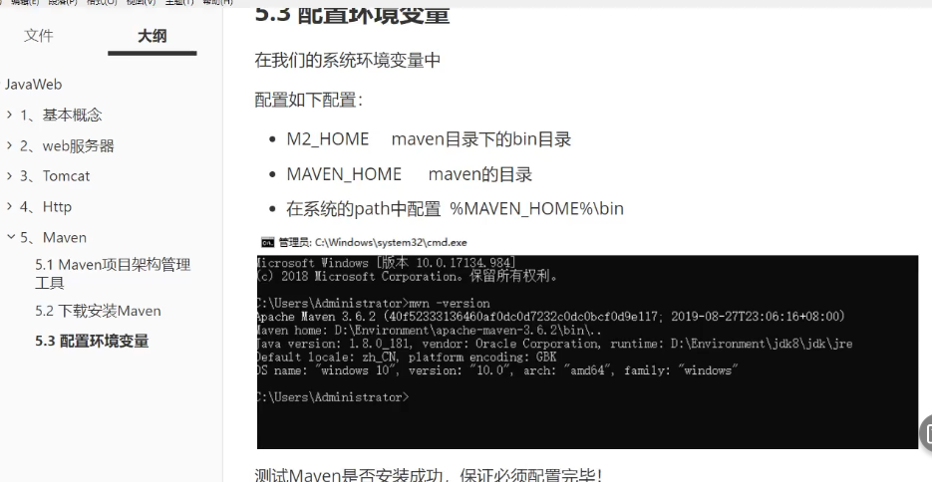

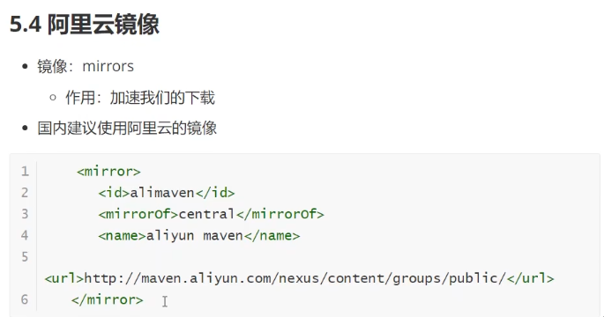

<mirror>

      <id>alimaven</id>

      <name>aliyun maven</name>

      <url>http://maven.aliyun.com/nexus/content/groups/public/</url>

      <mirrorOf>central</mirrorOf>

    </mirror>

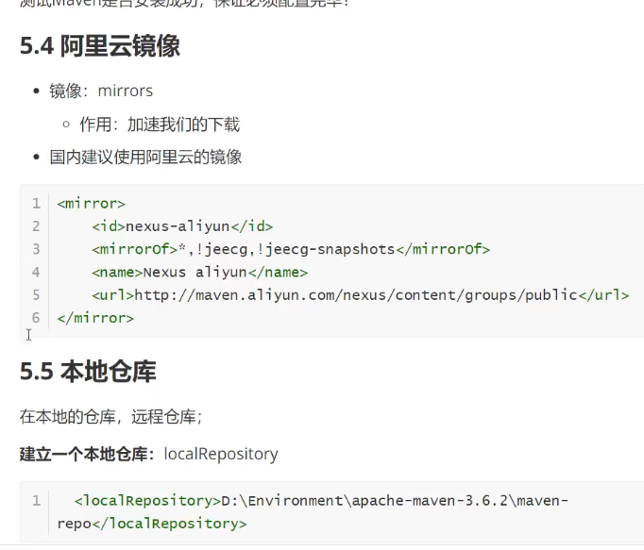

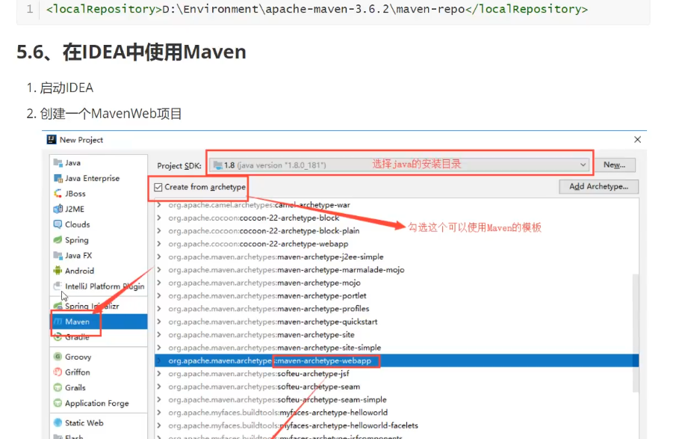

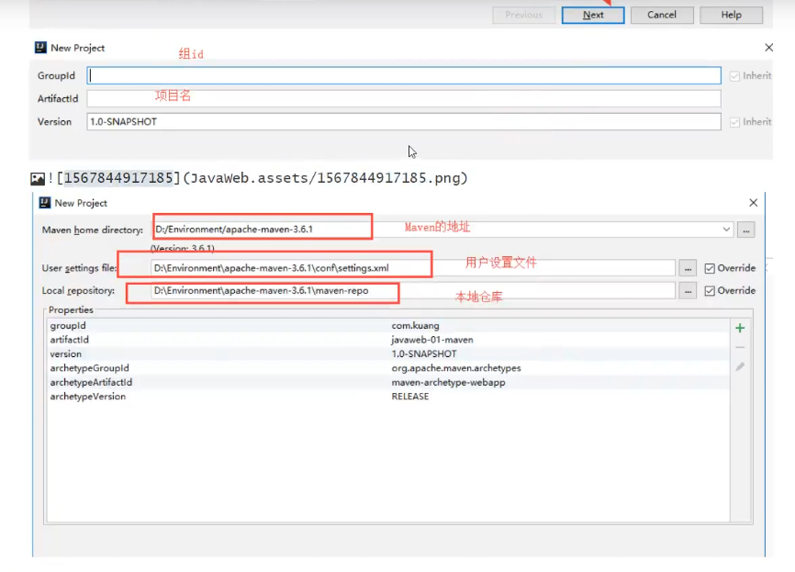

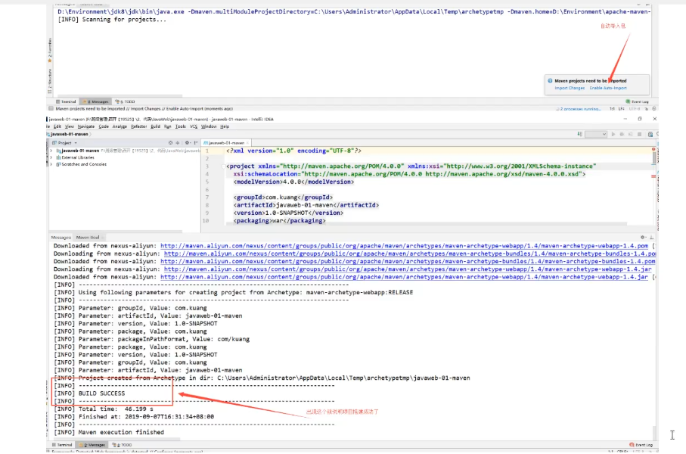

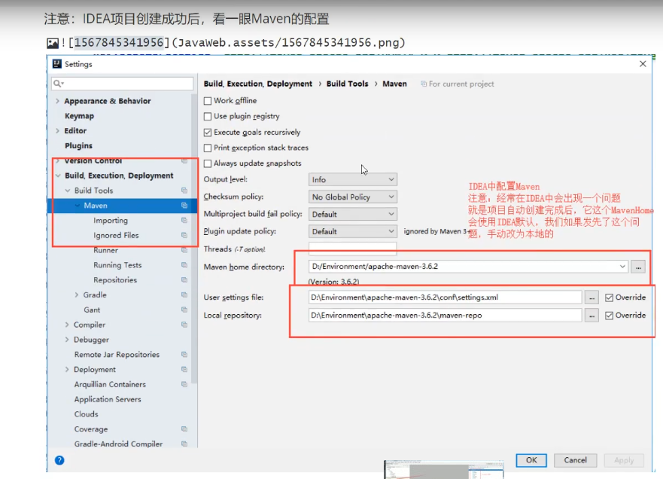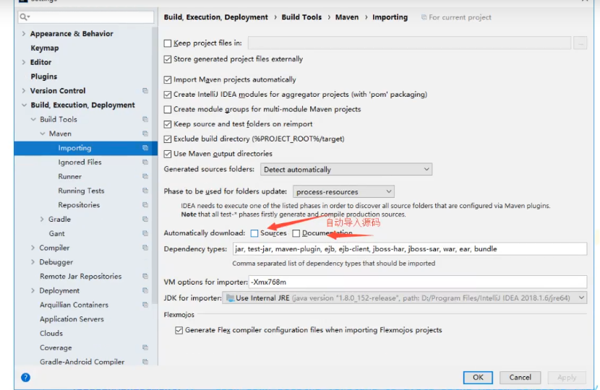

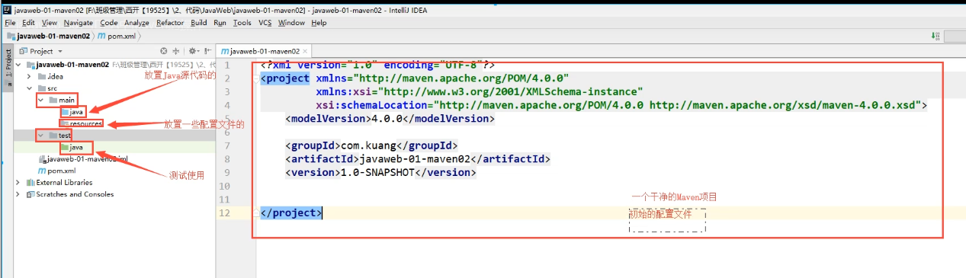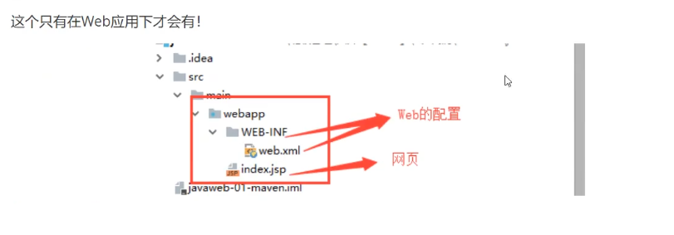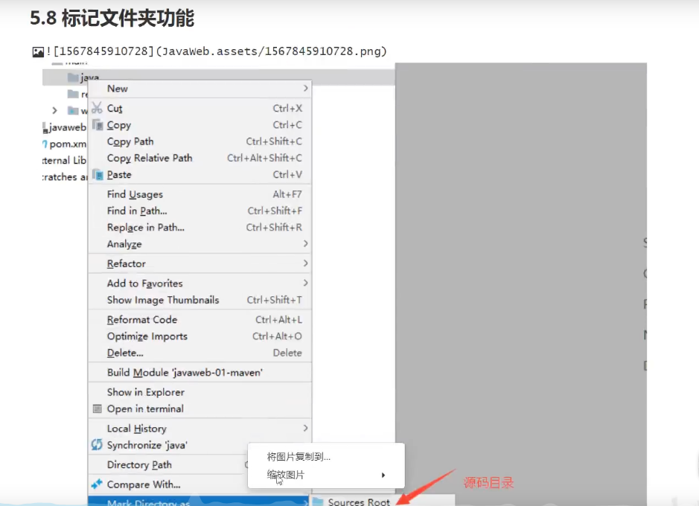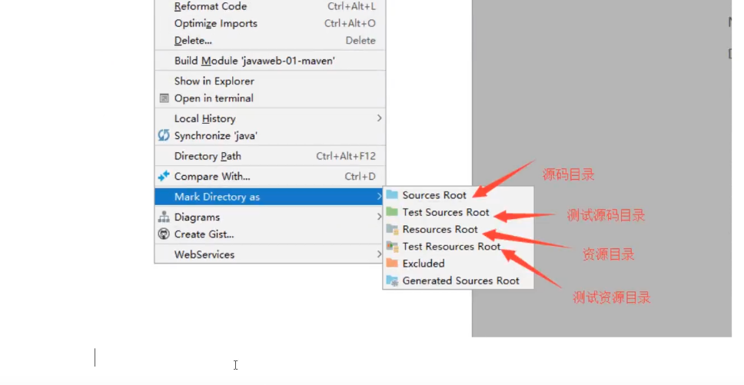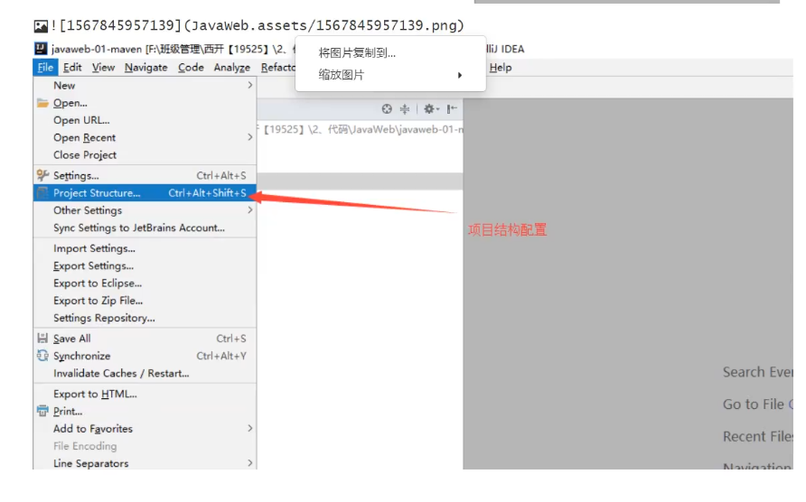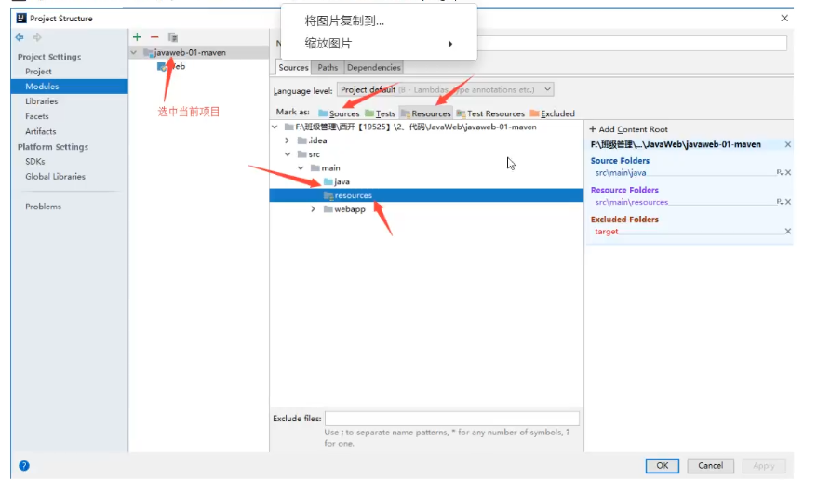

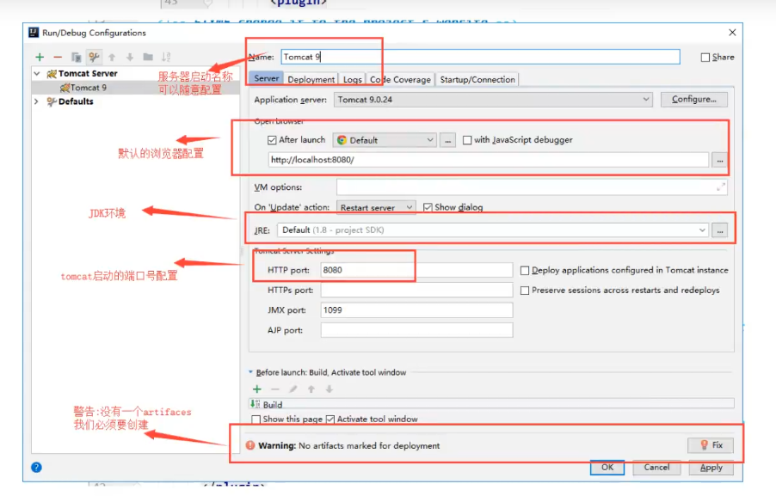

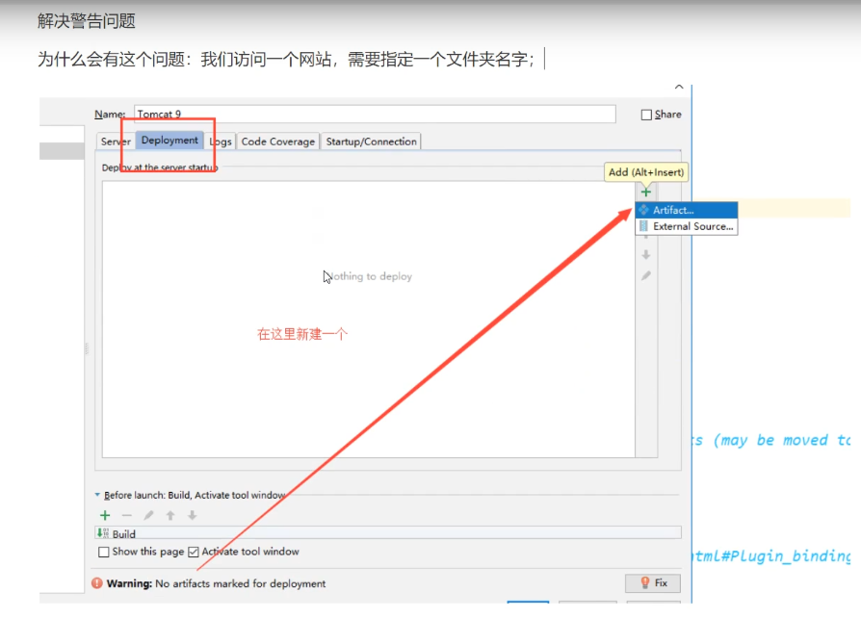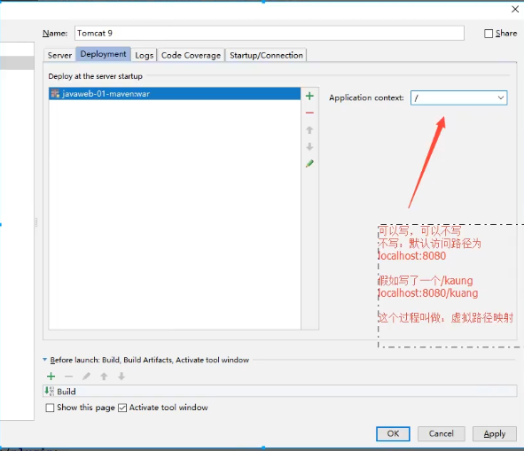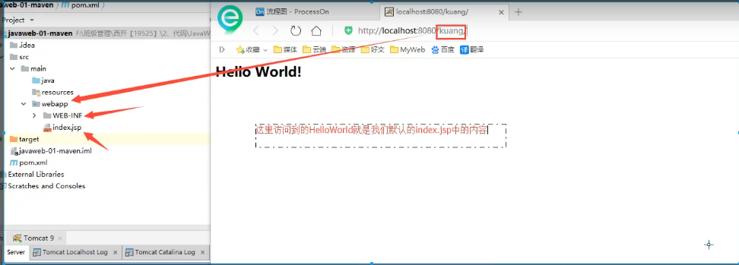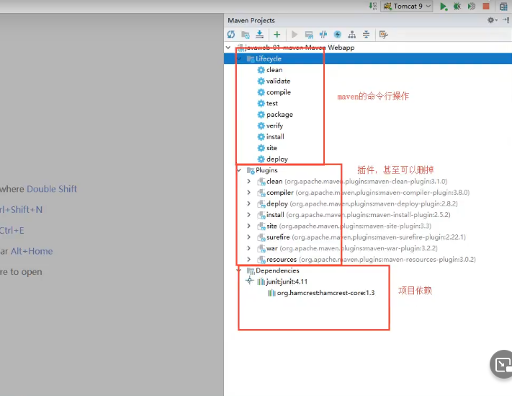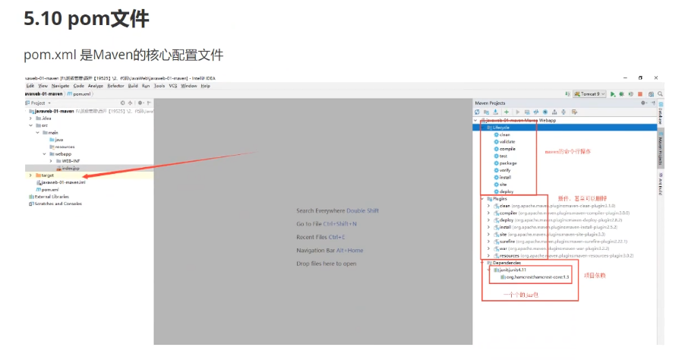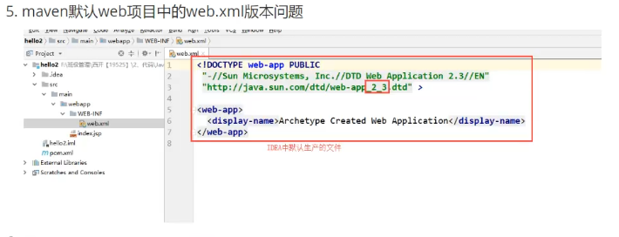

### 重！！！！！！！！！！

**<!DOCTYPE web-app PUBLIC**

**"-//Sun Microsystems, Inc.//DTD Web Application 2.3//EN"**

**"http://java.sun.com/dtd/web-app_2_3.dtd" *>***

<**web-app**>

<**display-name**>Archetype Created Web Application</**display-name**>

</**web-app**>

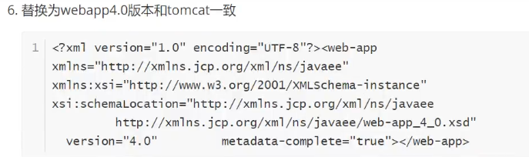

### 重！！！！！！！！！！

*<?***xml version="1.0" encoding="UTF-8"***?>*

<**web-app xmlns="http://xmlns.jcp.org/xml/ns/javaee"**

**xmlns:xsi="http://www.w3.org/2001/XMLSchema-instance"**

**xsi:schemaLocation="http://xmlns.jcp.org/xml/ns/javaee**

**http://xmlns.jcp.org/xml/ns/javaee/web-app_4_0.xsd"**

**version="4.0"**

**metadata-complete="true"**>

</**web-app**>

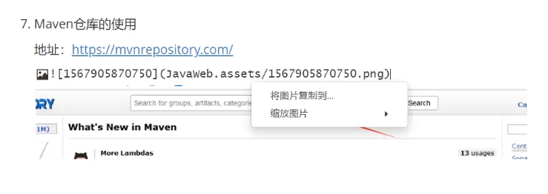

https://mvnrepository.com/

servlet-api：搜索框输入得到如下，选取使用人数最多的

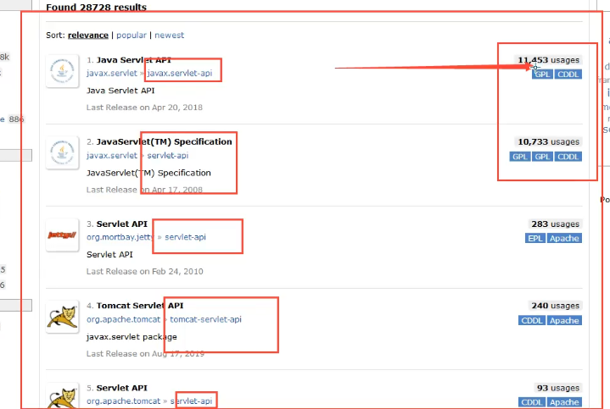

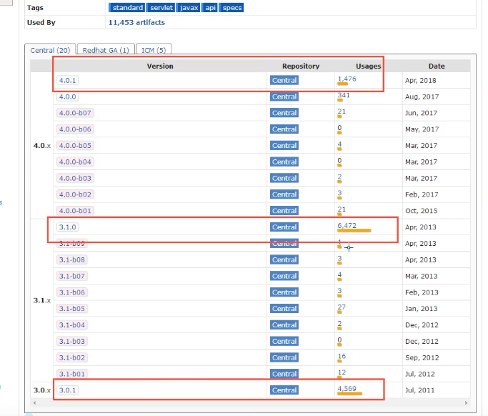

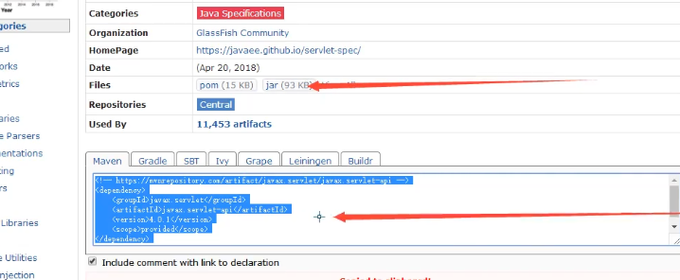

<!-- https://mvnrepository.com/artifact/javax.servlet/javax.servlet-api -->

<dependency>

<groupId>javax.servlet</groupId>

<artifactId>javax.servlet-api</artifactId>

<version>4.0.1</version>

<scope>provided</scope>

</dependency>

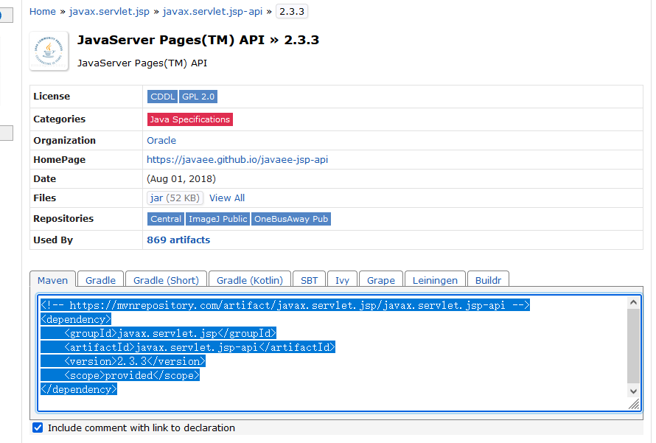

<!-- https://mvnrepository.com/artifact/javax.servlet.jsp/javax.servlet.jsp-api -->

<dependency>

<groupId>javax.servlet.jsp</groupId>

<artifactId>javax.servlet.jsp-api</artifactId>

<version>2.3.3</version>

<scope>provided</scope>

</dependency>

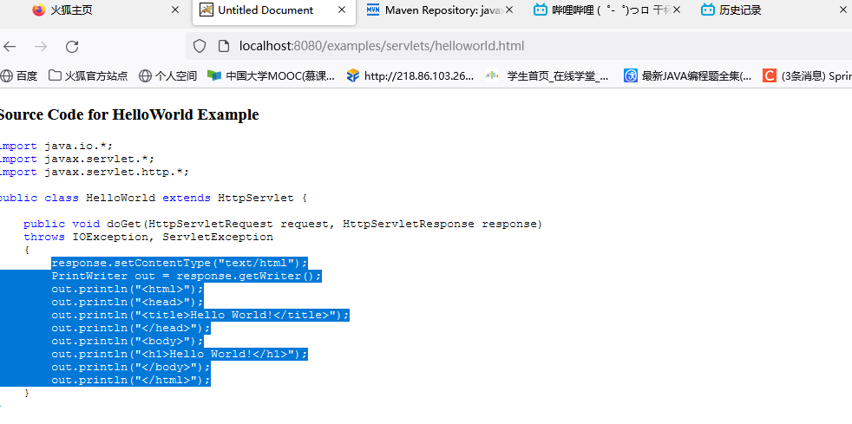

response.setContentType("text/html");

PrintWriter out = response.getWriter();

out.println("<html>");

out.println("<head>");

out.println("<title>Hello World!</title>");

out.println("</head>");

out.println("<body>");

out.println("<h1>Hello World!</h1>");

out.println("</body>");

out.println("</html>");

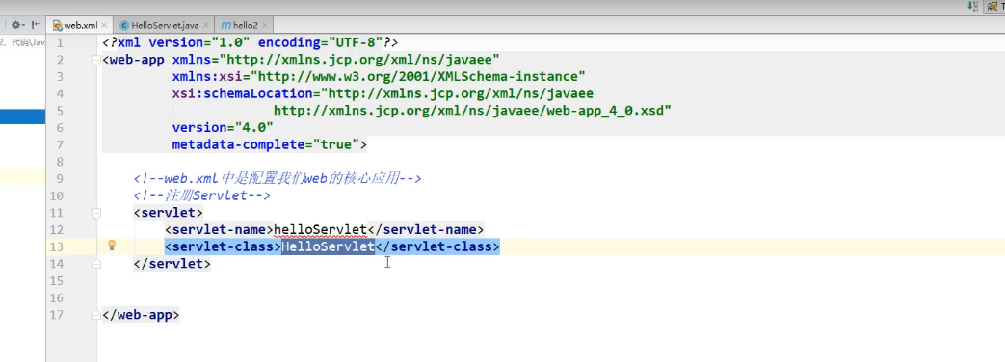

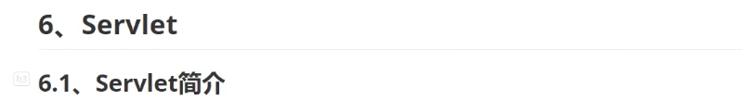

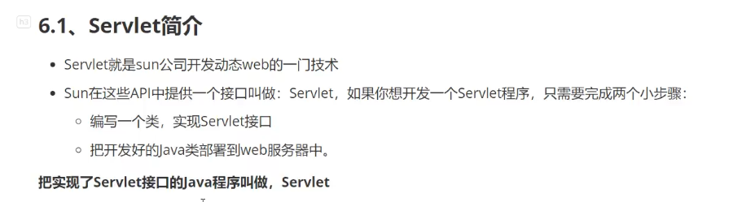

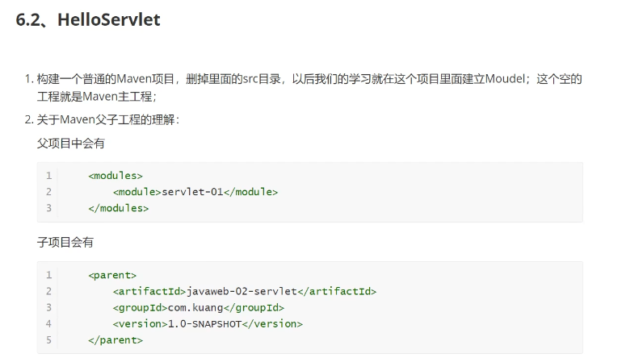

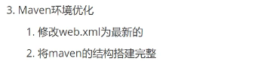

*<?***xml version="1.0" encoding="UTF-8"***?>*

<**web-app xmlns="http://xmlns.jcp.org/xml/ns/javaee"**

**xmlns:xsi="http://www.w3.org/2001/XMLSchema-instance"**

**xsi:schemaLocation="http://xmlns.jcp.org/xml/ns/javaee**

**http://xmlns.jcp.org/xml/ns/javaee/web-app_4_0.xsd"**

**version="4.0"**

**metadata-complete="true"**>

</**web-app**>



、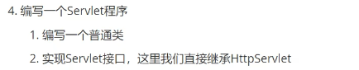

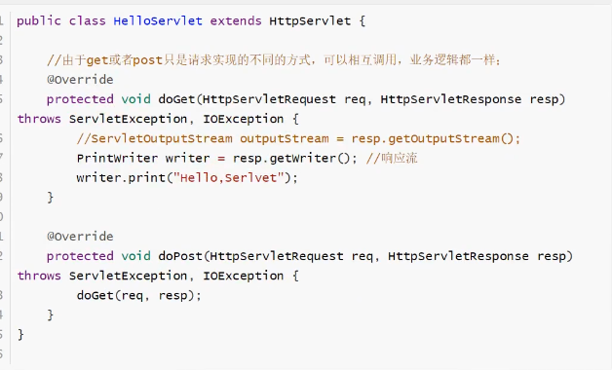

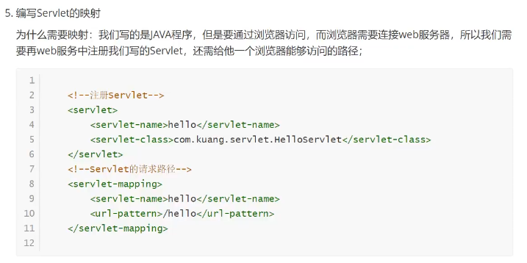

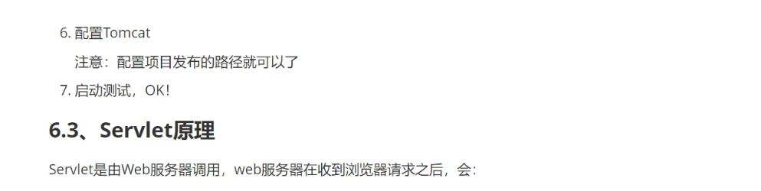

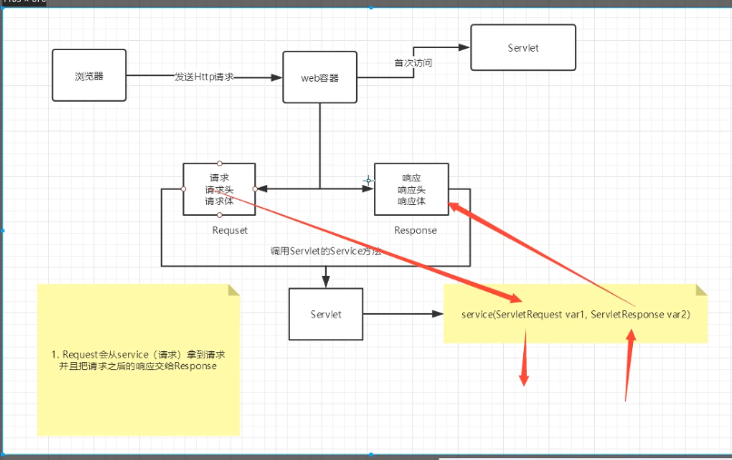

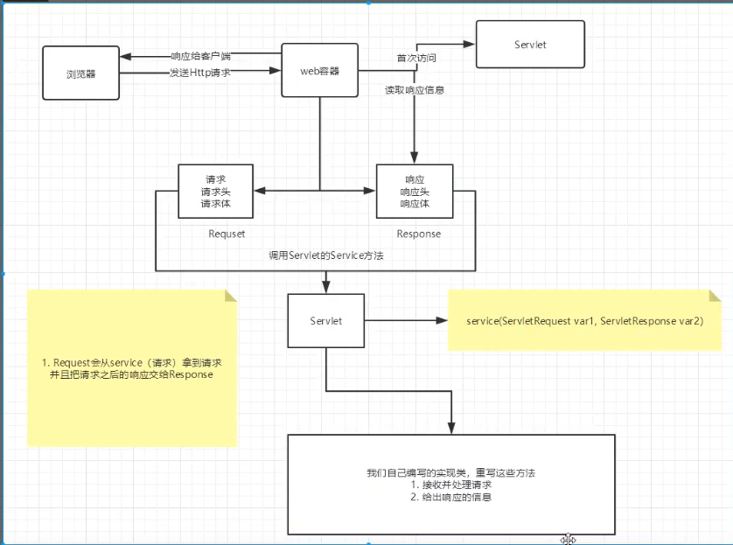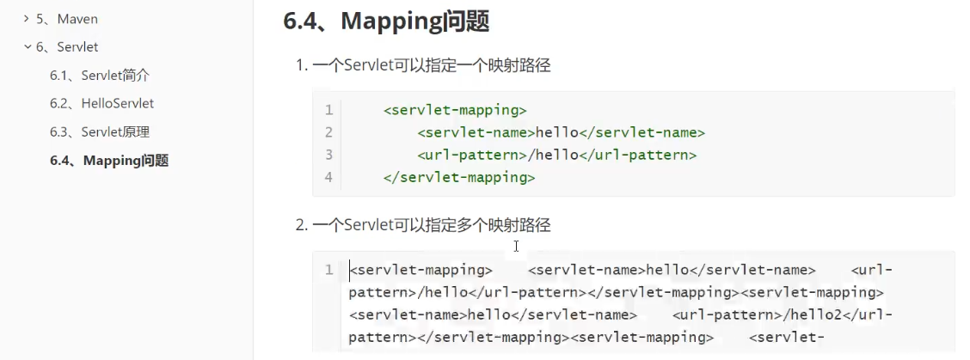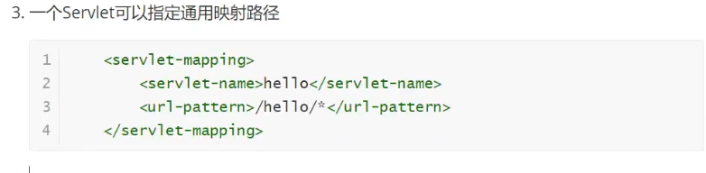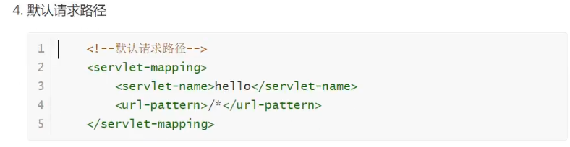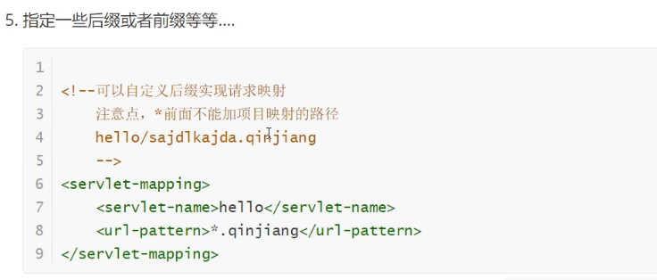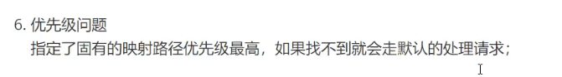

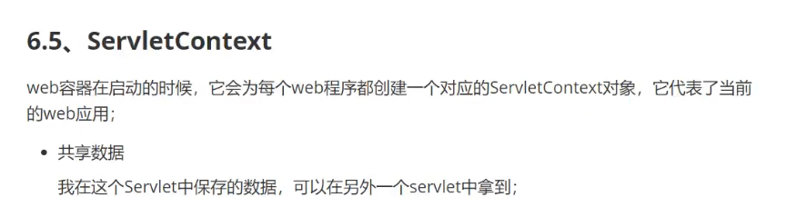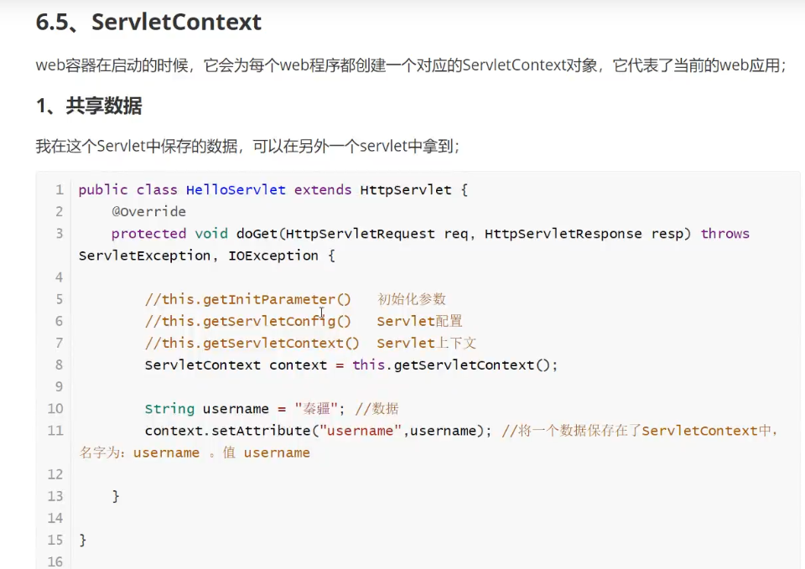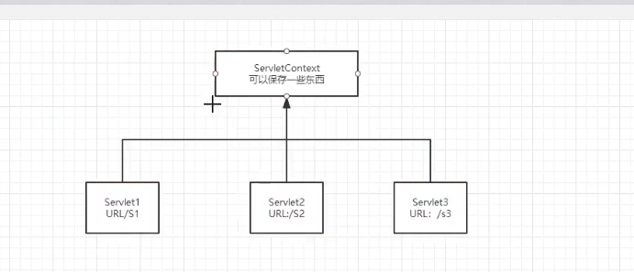

#### 需要导的依赖：

<**dependencies**>

<**dependency**>

<**groupId**>javax.servlet</**groupId**>

<**artifactId**>servlet-api</**artifactId**>

<**version**>2.5</**version**>

</**dependency**>

<**dependency**>

<**groupId**>javax.servlet.jsp</**groupId**>

<**artifactId**>javax.servlet.jsp-api</**artifactId**>

<**version**>2.3.3</**version**>

</**dependency**>

</**dependencies**>

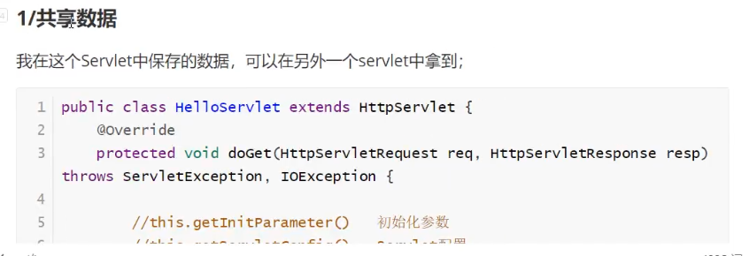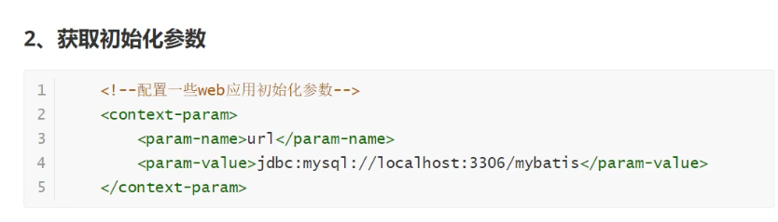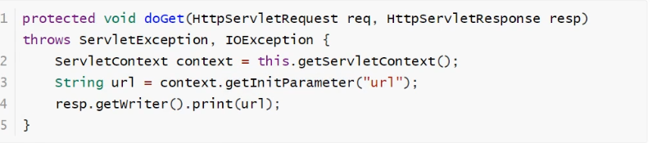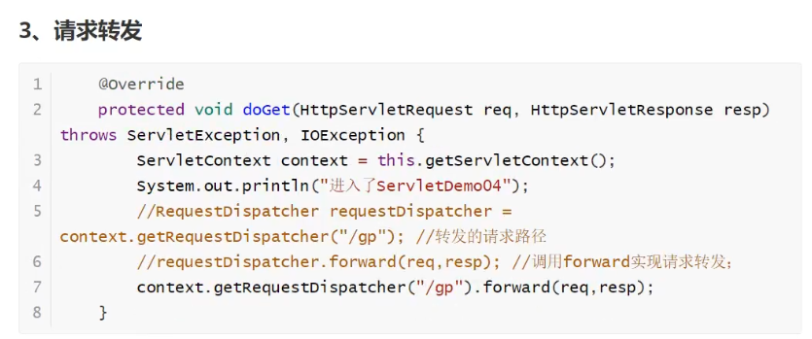

请求转发

重定向

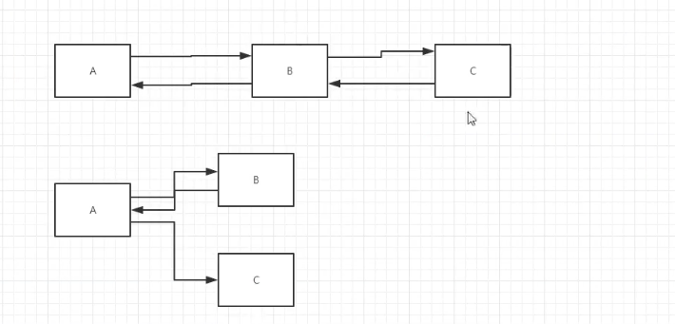

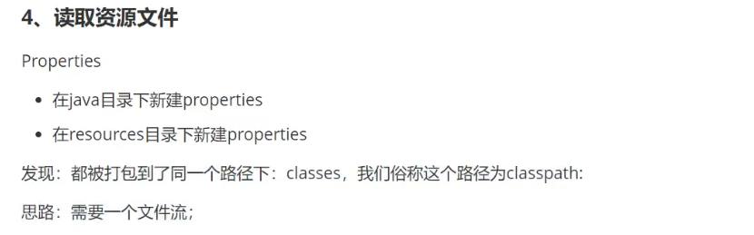

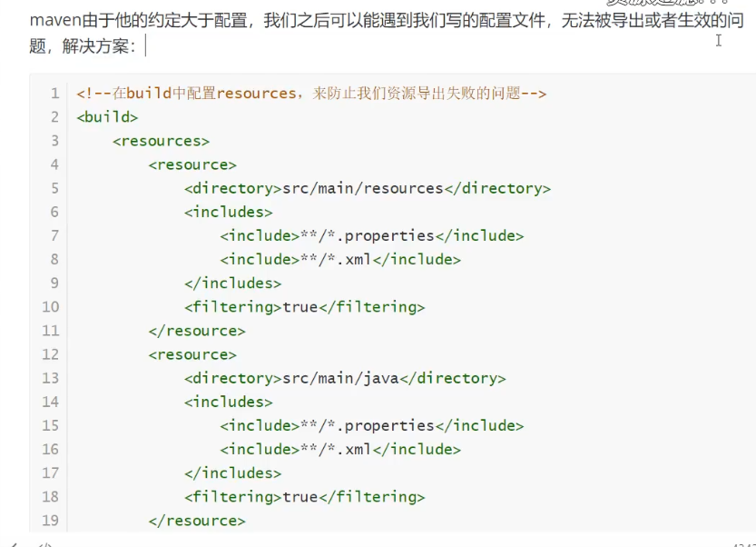

<build>

<resources>

<resource>

<directory>src/main/resources</directory>

<includes>

<include>**/*.properties</include>

<include>**/*.xml</include>

</includes>

</resource>

<resource>

<directory>src/main/java</directory>

<includes>

<include>**/*.properties</include>

<include>**/*.xml</include>

</includes>

</resource>

</resources>

</build>

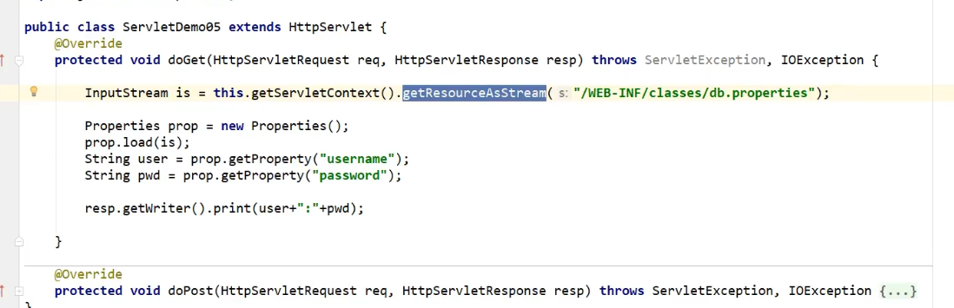

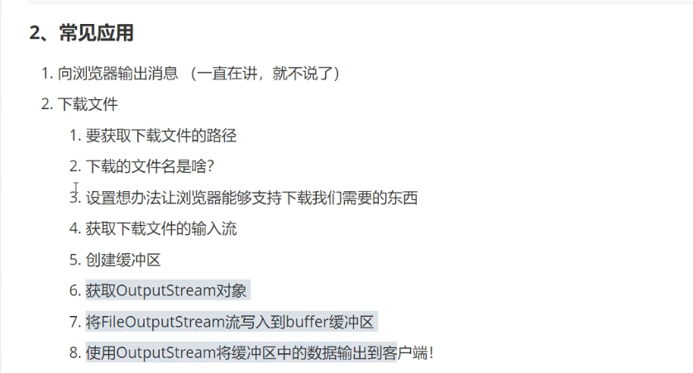

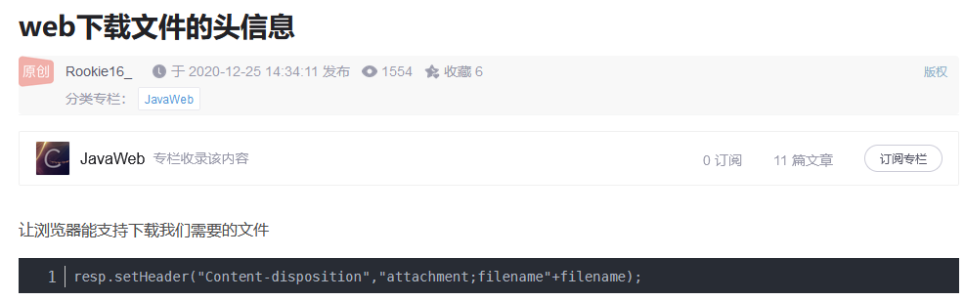resp.setHeader("Content-disposition","attachment;filename"+ URLEncoder.encode(filename));

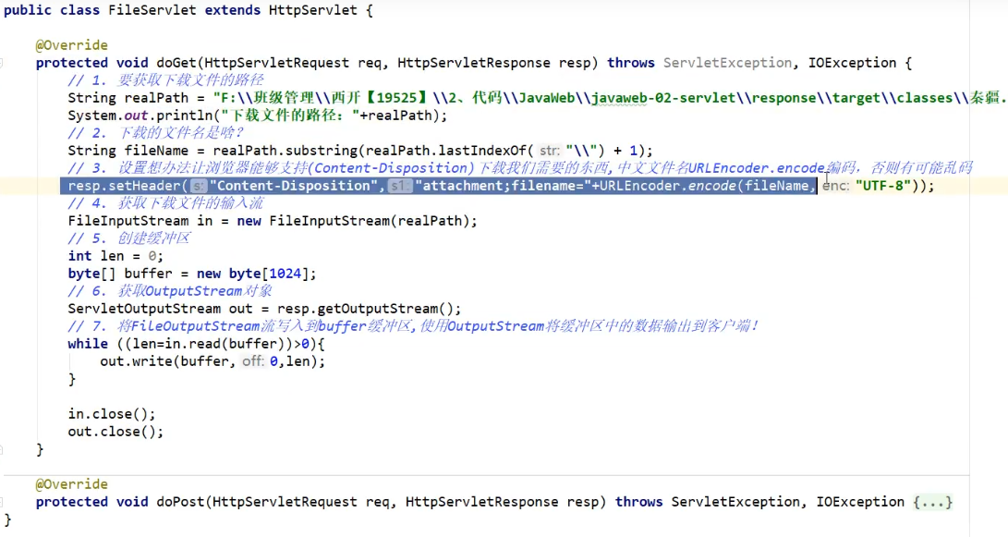

**public class** FileServlet **extends** HttpServlet {

@Override

**protected void** doGet(HttpServletRequest req, HttpServletResponse resp) **throws** ServletException, IOException {

*//1.获取加载文件的路径*

String realPath=**"D:\\javaweb\\daima\\javaweb-003\\respsonse\\target\\classes\\1.png"**;

System.***out***.println(**"下载的文件的路径："**+realPath);

*//2.下载文件名称是啥？*

String fileName= realPath.substring(realPath.lastIndexOf(**"//"**)+1);*//substring截取*

*//3.设置想办法让浏览器能够支持下载我们所需要的东西*

resp.setHeader(**"Content-disposition"**,**"attachment;filename"**+fileName);

*//4.获取文件的输入流*

FileInputStream in=**new** FileInputStream(realPath);

*//5.创建缓冲区*

**int** len=0;

**byte**[] buffer=**new byte**[1024];

*//6.获取OutputStream对象*

ServletOutputStream out=resp.getOutputStream();

*//7.将FileOutputStream流写入到buffer缓冲区,使用OutPutStram将缓冲区的数据输出到客户端*

**while**((len=in.read(buffer))>0){

out.write(buffer,0,len);

}

in.close();

out.close();

*//8.使用OutputStream将缓冲区中的数据输出到客户端！*

}

@Override

**protected void** doPost(HttpServletRequest req, HttpServletResponse resp) **throws** ServletException, IOException {

doGet(req, resp);

}

}

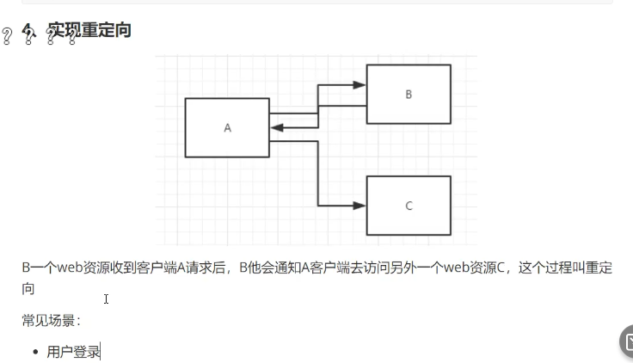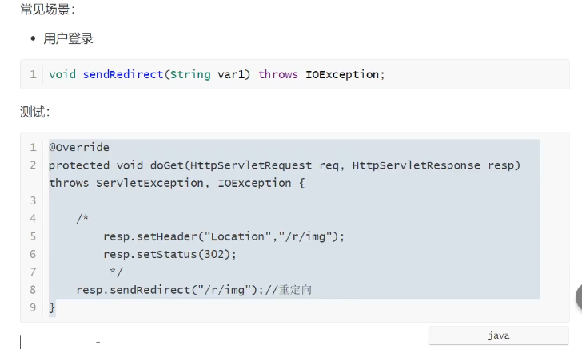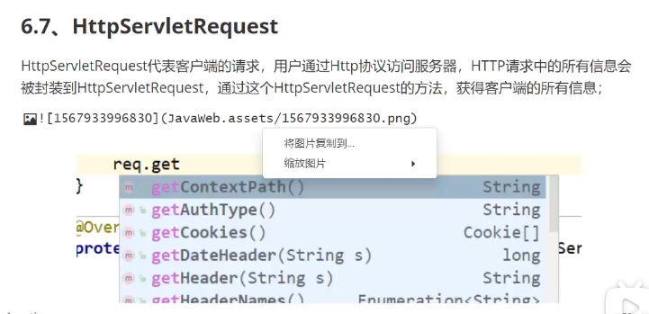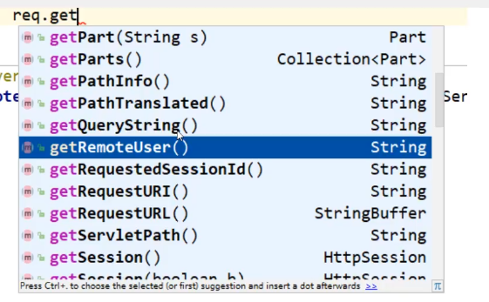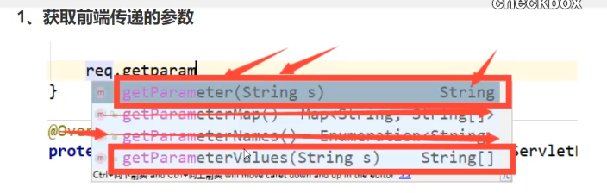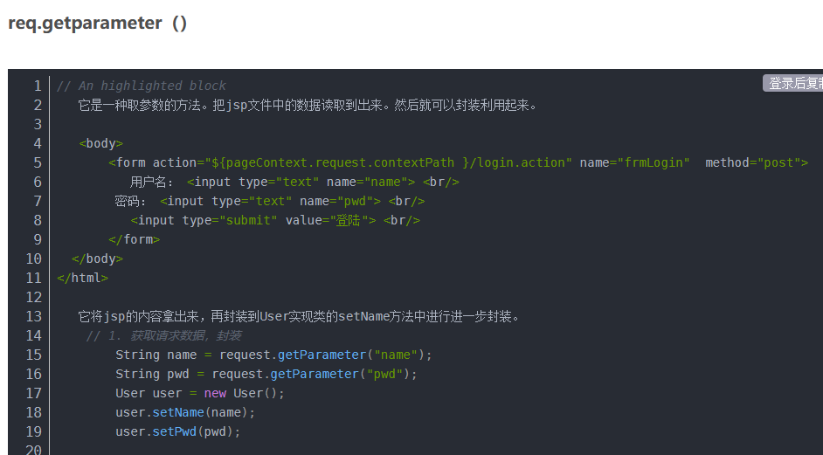

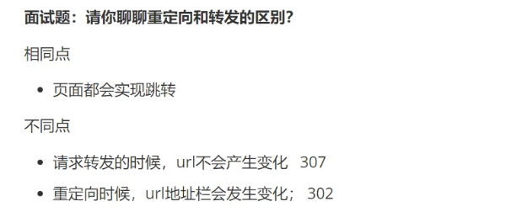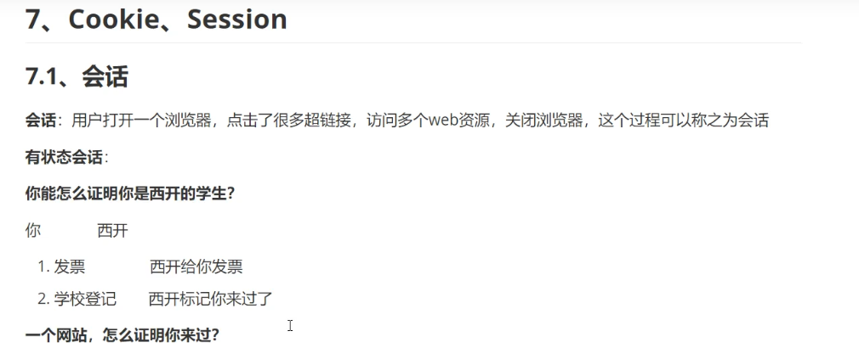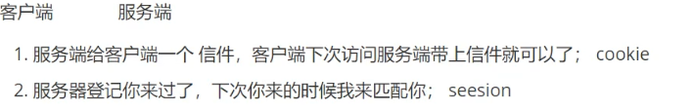

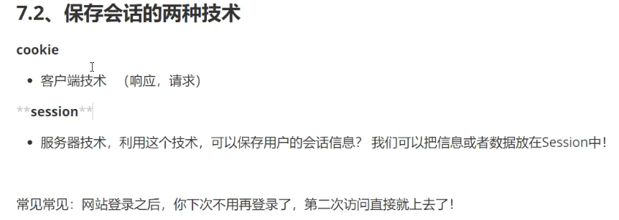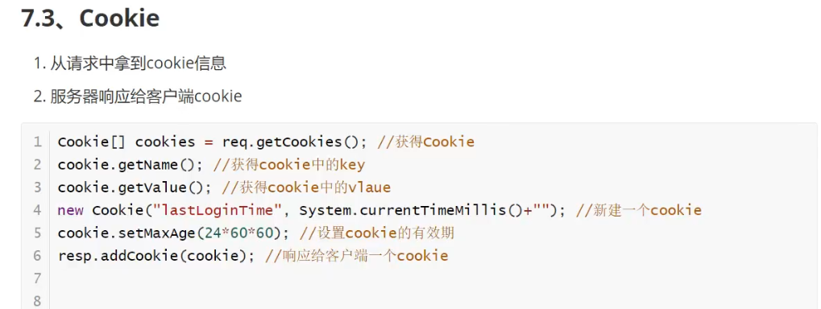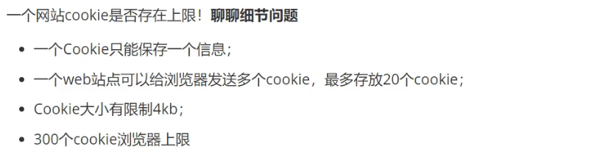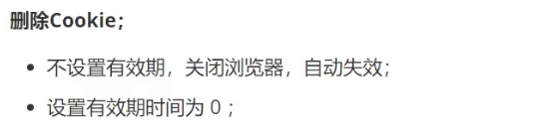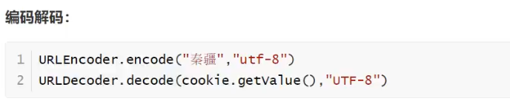

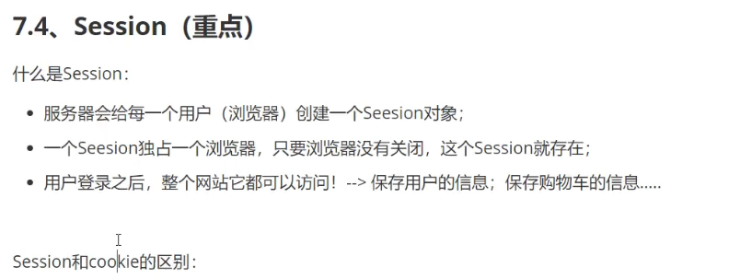

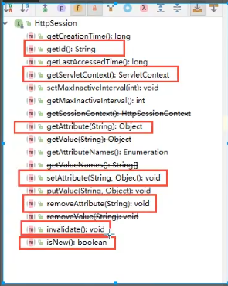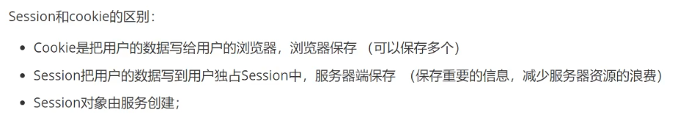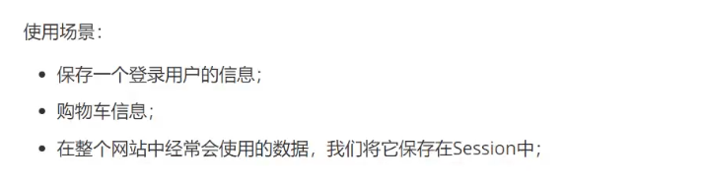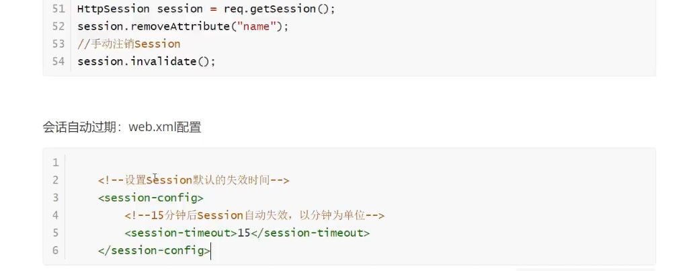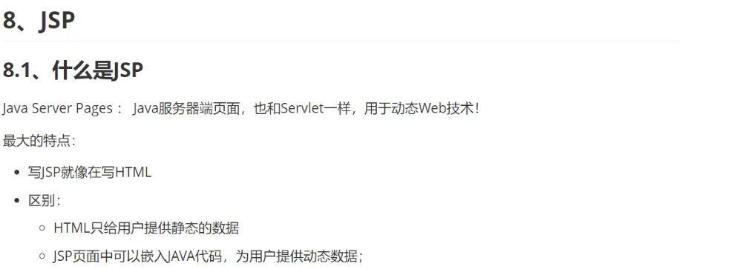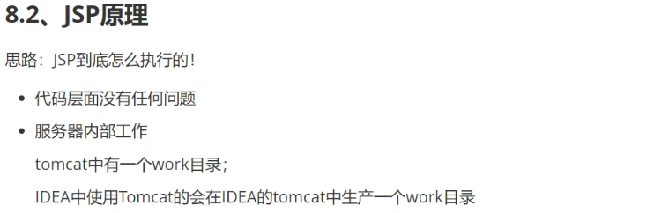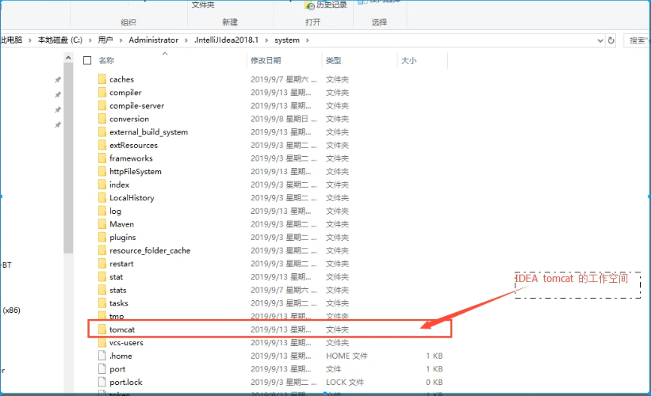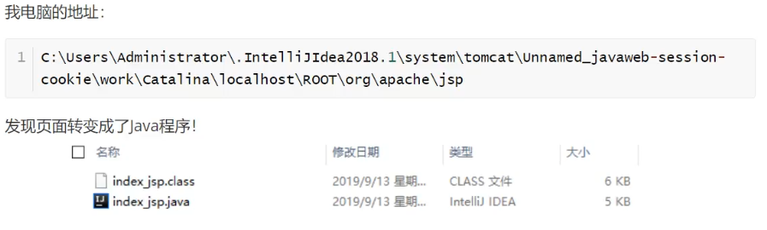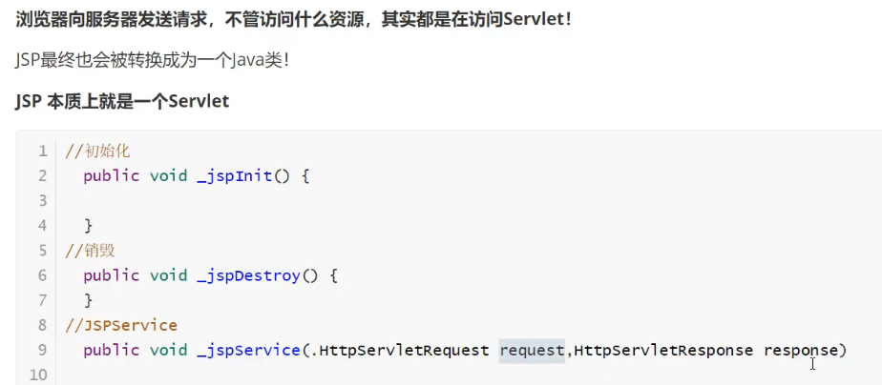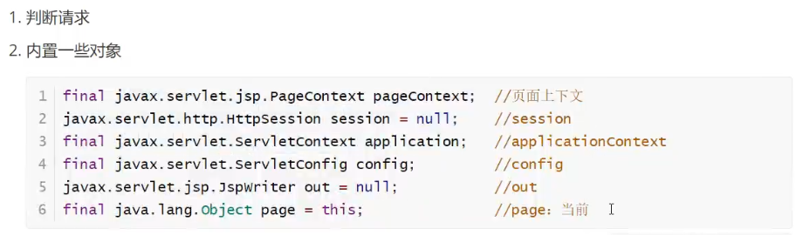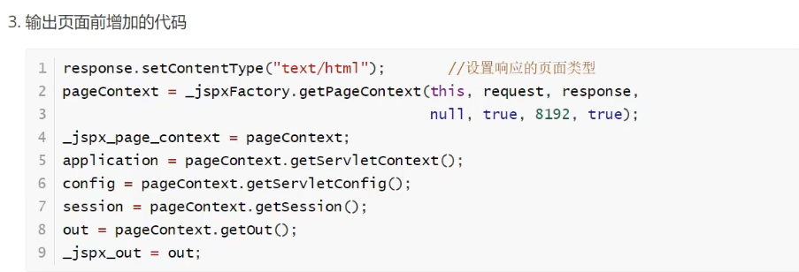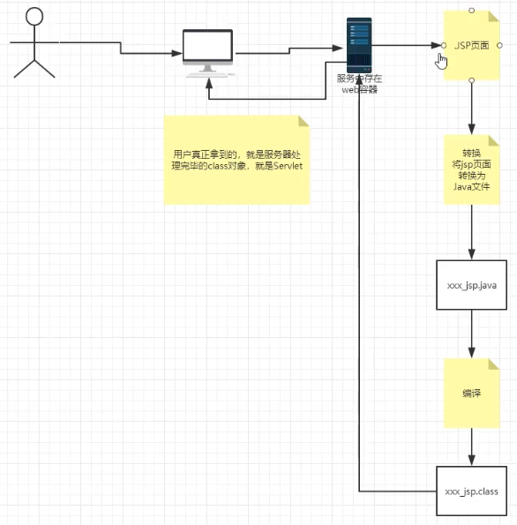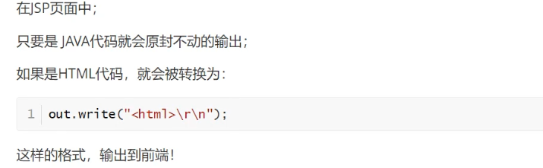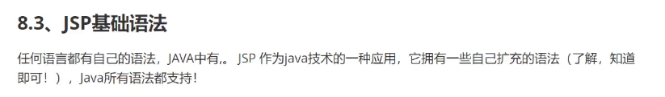

##### 依赖

<**dependencies**>

*<!--Servlet依赖-->*

<**dependency**>

<**groupId**>javax.servlet</**groupId**>

<**artifactId**>servlet-api</**artifactId**>

<**version**>2.5</**version**>

</**dependency**>

*<!--jsp依赖-->*

<**dependency**>

<**groupId**>javax.servlet.jsp</**groupId**>

<**artifactId**>javax.servlet.jsp-api</**artifactId**>

<**version**>2.3.3</**version**>

</**dependency**>

*<!--JSTL依赖-->*

<**dependency**>

<**groupId**>javax.servlet.jsp.jstl</**groupId**>

<**artifactId**>jstl-api</**artifactId**>

<**version**>1.2</**version**>

</**dependency**>

*<!--taglibs标签库-->*

<**dependency**>

<**groupId**>taglibs</**groupId**>

<**artifactId**>standard</**artifactId**>

<**version**>1.1.2</**version**>

</**dependency**>

</**dependencies**>

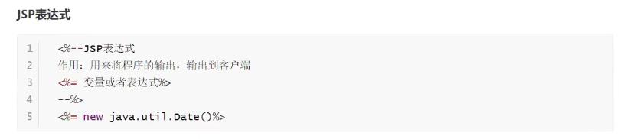

**Jsp：**

<%@ **page contentType**="**text/html; charset=UTF-8**" **language**="**java**" %>

<**html**>

<**body**>

<**h2**>Hello World!</**h2**>

</**body**>

</**html**>

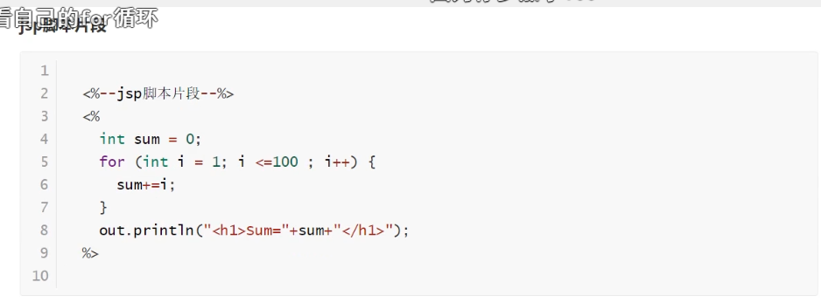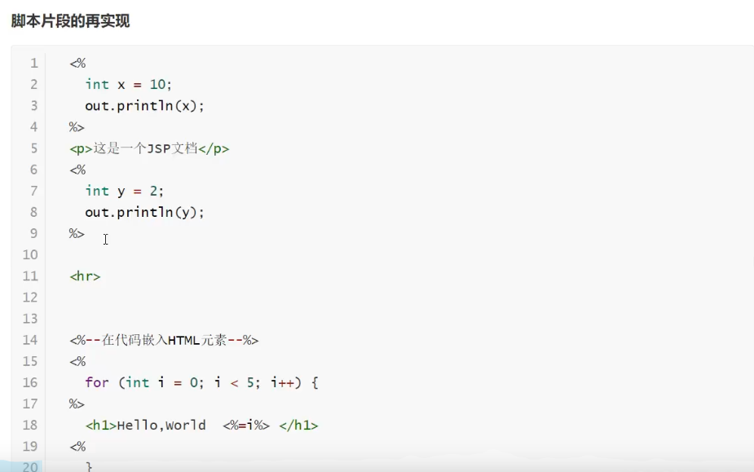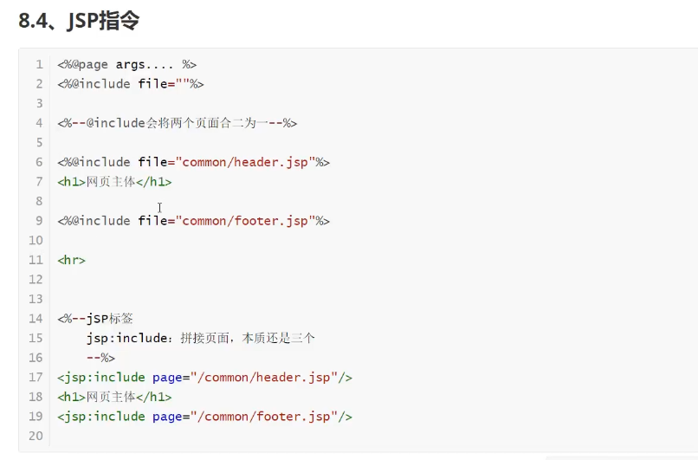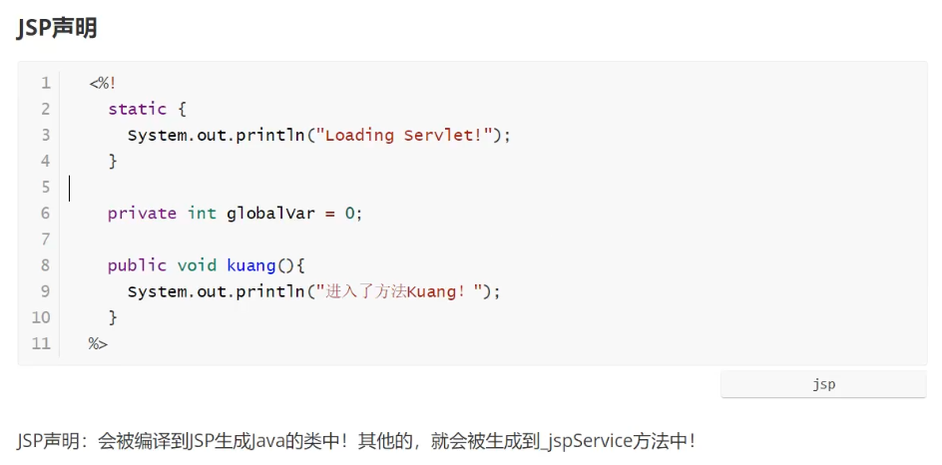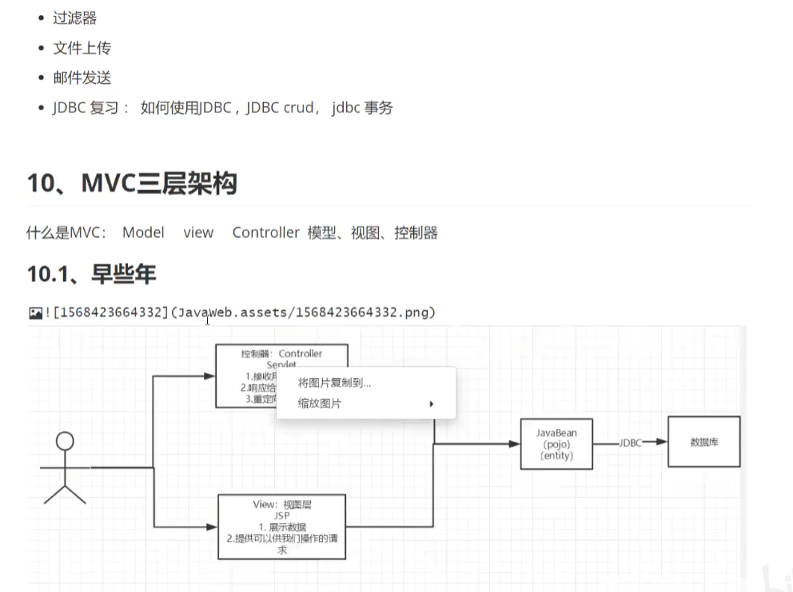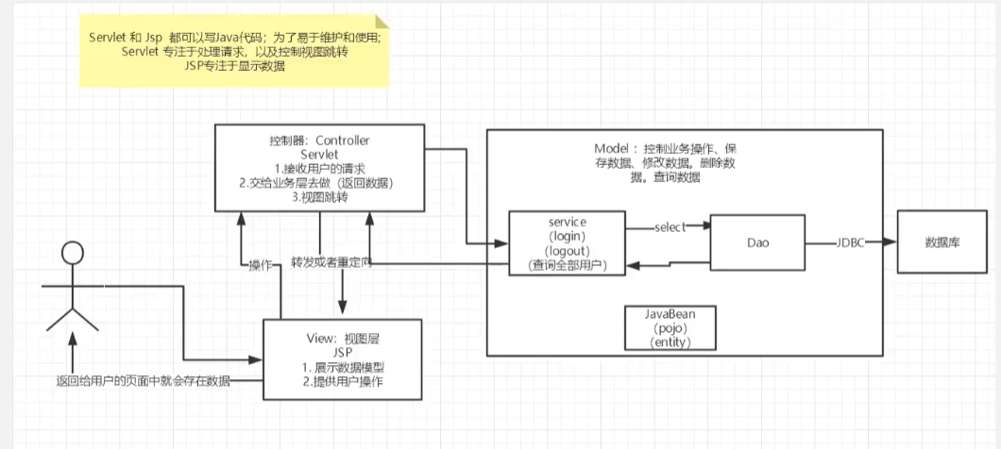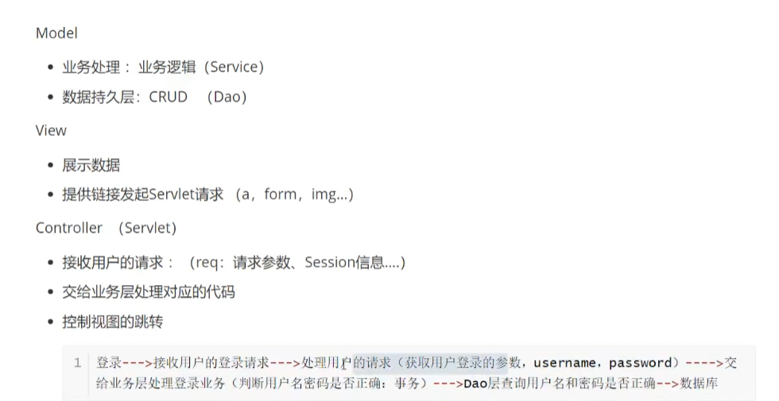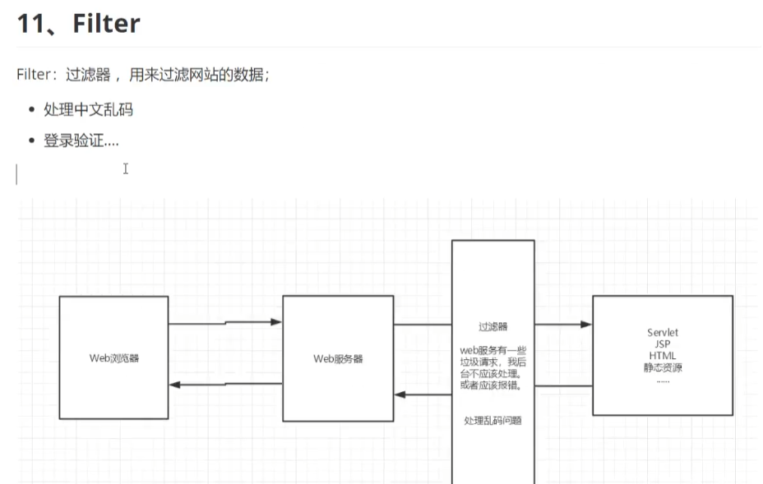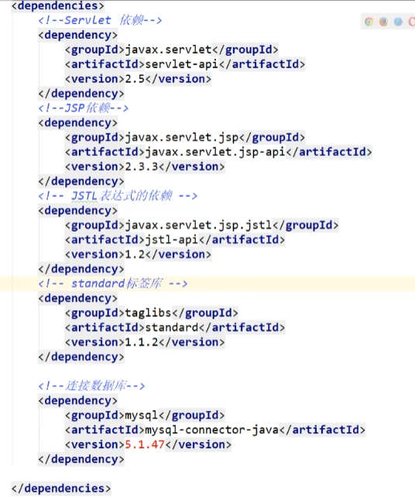

### 连接数据库依赖：

<**dependency**>

<**groupId**>mysql</**groupId**>

<**artifactId**>mysql-connector-java</**artifactId**>

<**version**>8.0.28</**version**>

</**dependency**>

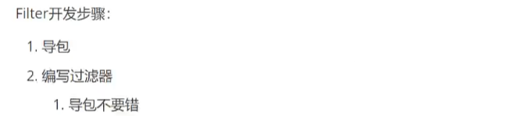

**不能导错包：**

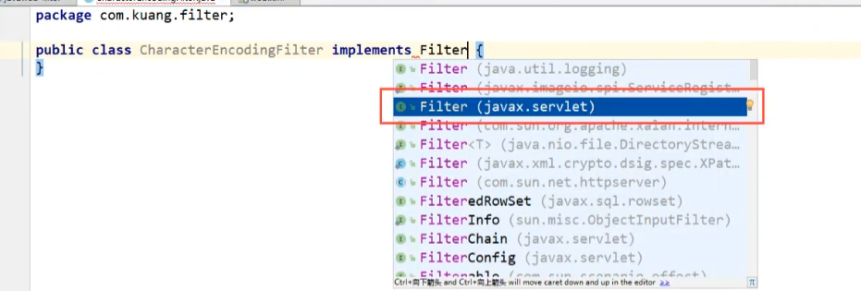

init():初始化



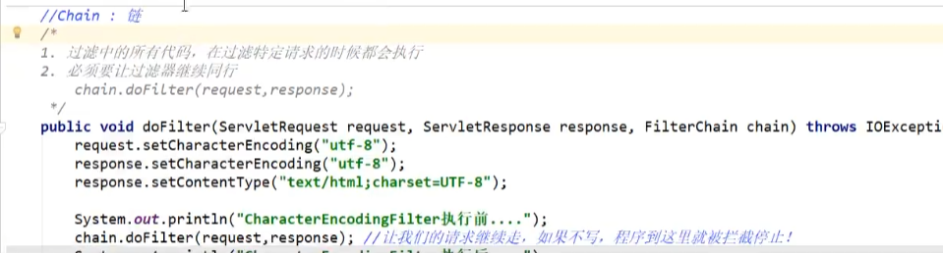**public class** CharacterEncodingFilter **implements** Filter {

*//初始化:web服务器启动，就已经初始化了，随时等待过滤对象出现！*

**public void** init(FilterConfig filterConfig) **throws** ServletException {

}

**public void** doFilter(ServletRequest servletRequest, ServletResponse servletResponse, FilterChain filterChain) **throws** IOException, ServletException {

servletRequest.setCharacterEncoding(**"GBK"**);

servletResponse.setCharacterEncoding(**"GBK"**);

servletResponse.setContentType(**"text/html;charset=GBK"**);

System.***out***.println(**"CharacterEncodingFilter执行前。。。。。"**);

filterChain.doFilter(servletRequest,servletResponse);*//让我们请求继续走你，如果不写，程序到这里就被截止了*

System.***out***.println(**"CharacterEncodingFilter执行后。。。。。"**);

}

*//销毁*

**public void** destroy() {

}

}

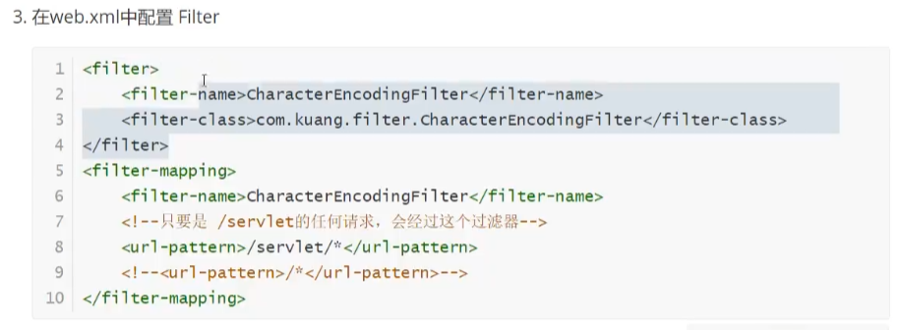

<**filter**>

<**filter-name**>CharacterEncodingFilter</**filter-name**>

<**filter-class**>com.xuzefeng.filter.CharacterEncodingFilter</**filter-class**>

</**filter**>

<**filter-mapping**>

<**filter-name**>CharacterEncodingFilter</**filter-name**>

<**url-pattern**>/servlet/*</**url-pattern**>

</**filter-mapping**>

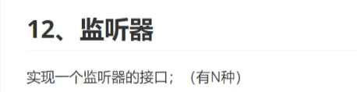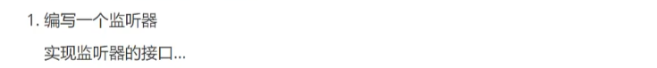**public class** OnlineCountListener **implements** HttpSessionListener {

*//创建session的监听*

*//一旦创建session就会触发一次这个事件*

@Override

**public void** sessionCreated(HttpSessionEvent httpSessionEvent) {

ServletContext ctx=httpSessionEvent.getSession().getServletContext();

Integer onlineCount=(Integer) ctx.getAttribute(**"OnlineCount"**);

**if** (onlineCount==**null**){

onlineCount=**new** Integer(1);

System.***out***.println(onlineCount);

}**else** {

**int** count=onlineCount.intValue();

onlineCount=**new** Integer(count+1);

}

ctx.setAttribute(**"OnlineCount"**,onlineCount);

}

*//销毁session的监听*

@Override

**public void** sessionDestroyed(HttpSessionEvent httpSessionEvent) {

ServletContext ctx=httpSessionEvent.getSession().getServletContext();

Integer onlineCount=(Integer) ctx.getAttribute(**"OnlineCount"**);

**if** (onlineCount==**null**){

onlineCount=**new** Integer(0);

}**else** {

**int** count=onlineCount.intValue();

onlineCount=**new** Integer(count-1);

}

ctx.setAttribute(**"OnlineCount"**,onlineCount);

}

}

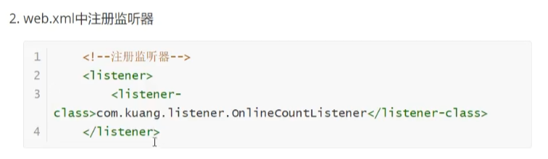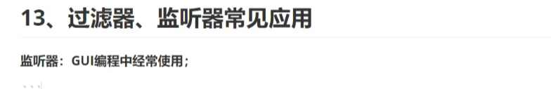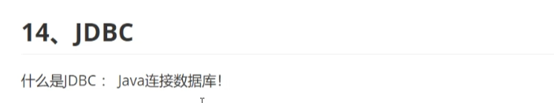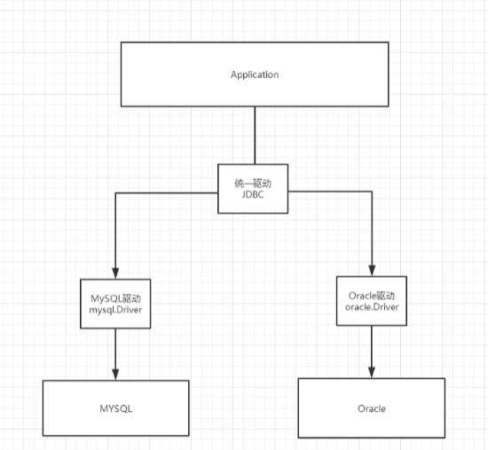

## 数据库依赖

<**dependency**>

<**groupId**>mysql</**groupId**>

<**artifactId**>mysql-connector-java</**artifactId**>

<**version**>5.1.47</**version**>

</**dependency**>

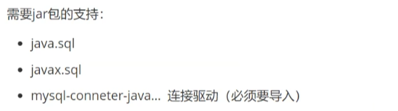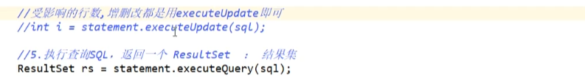

**public class** TestJbdc {

**public static void** main(String[] args) **throws** ClassNotFoundException, SQLException {

*//配置信息*

*//useUnicode=true&characterEncoding=gbk";：解决中文乱码问题*

String url=**"jdbc:mysql://localhost:3306/jdbc?useUnicode=true&characterEncoding=gbk"**;

String username=**"root"**;

String password=**"123456"**;

*//1.加载驱动*

Class.*forName*(**"com.mysql.jdbc.Driver"**);

*//2.连接数据库*

Connection connection= DriverManager.*getConnection*(url,username,password);

*//3.向数据库发送SQL的对象Statement：CRUD*

Statement statement=connection.createStatement();

*//编写SQL*

String sql=**"select** *\** **from users"**;

*//执行查询SQL，返回一个ResultSet:结果集*

ResultSet resultSet= statement.executeQuery(sql);

**while** (resultSet.next()){

System.***out***.println(**"id="**+resultSet.getObject(**"id"**));

System.***out***.println(**"name="**+resultSet.getObject(**"name"**));

System.***out***.println(**"password="**+resultSet.getObject(**"password"**));

System.***out***.println(**"email="**+resultSet.getObject(**"email"**));

System.***out***.println(**"birthday="**+resultSet.getObject(**"birthday"**));

}

*//6.关闭连接，释放资源（一定要做）先开后关*

resultSet.close();

statement.close();

connection.close();

}

}

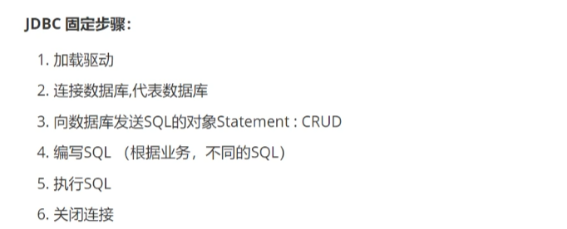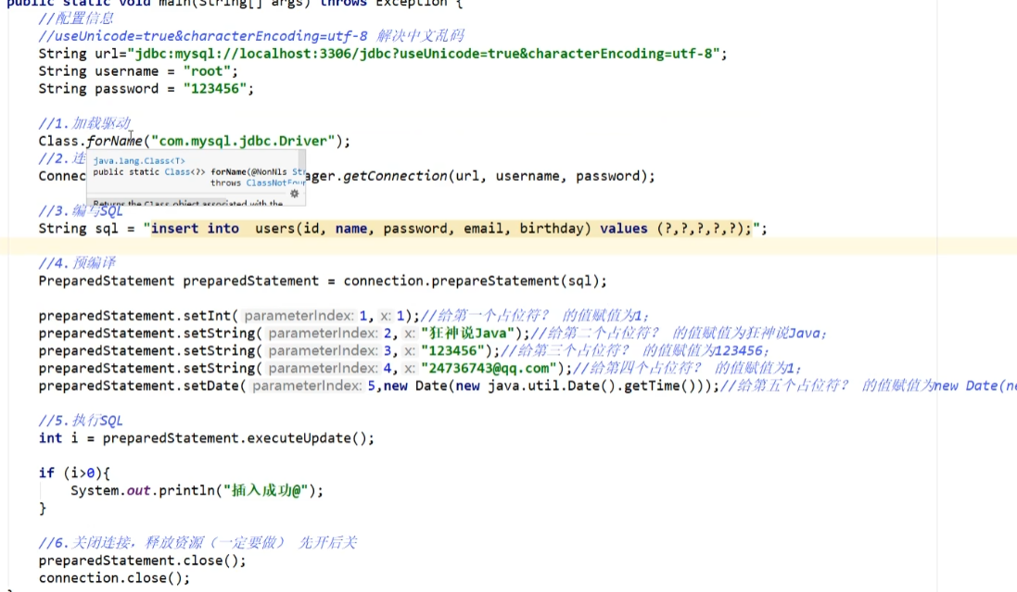

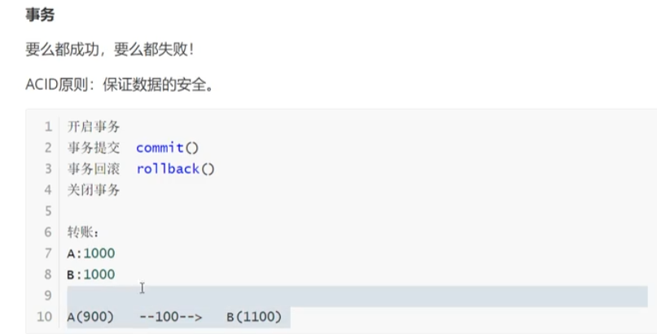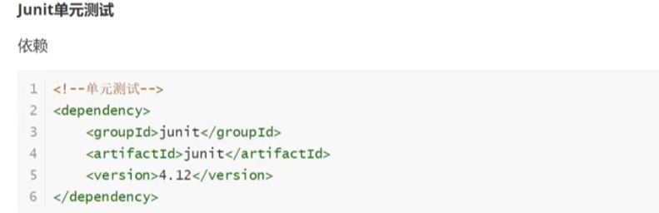

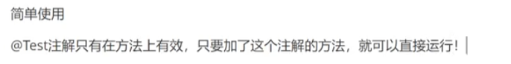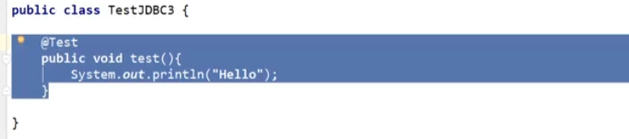

### 单元测试依赖：

*<!--单元测试-->*

<**dependency**>

<**groupId**>junit</**groupId**>

<**artifactId**>junit</**artifactId**>

<**version**>4.12</**version**>

<**scope**>test</**scope**>

</**dependency**>

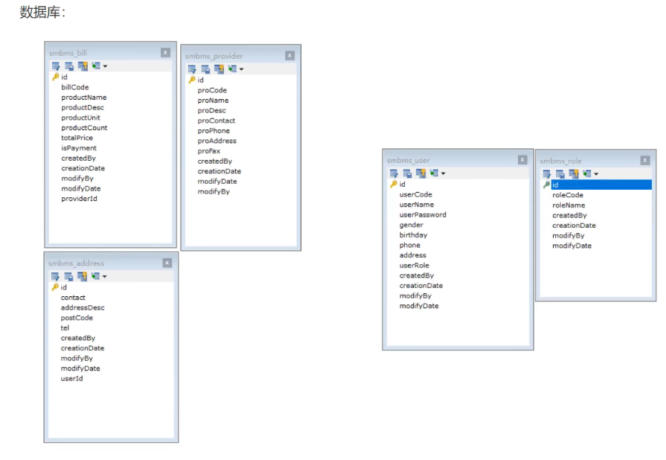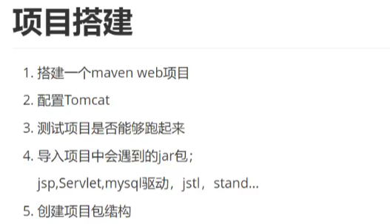

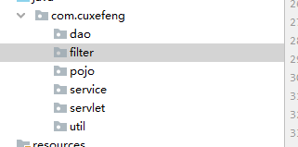实体类：pojo;操作数据库：dao;filter:过滤器；util:工具类；serveice：业务

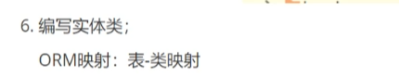

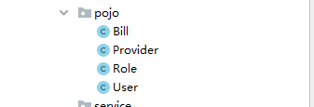

##### **driver**=**com.mysql.jdbc.Driver**

##### **url**=**jdbc:mysql://localhost:3306?useUnicode=true&characterEncoding=gbk**

##### **username**=**root**

##### **password**=**123456**

#### 

*//操作数据库的公共类*

**public class** BaseDao {

**private static** String *driver*;

**private static** String *url*;

**private static** String *username*;

**private static** String *password*;

*//静态代码块，类加载的时候就初始化了*

**static** {

Properties properties=**new** Properties();

*//通过类加载器读取对应的资源*

InputStream is= BaseDao.**class**.getClassLoader().getResourceAsStream(**"db.properties"**);

**try** {

properties.load(is);

} **catch** (IOException e) {

e.printStackTrace();

}

*driver*=properties.getProperty(**"driver"**);

*url*=properties.getProperty(**"url"**);

*username*=properties.getProperty(**"username"**);

*password*=properties.getProperty(**"password"**);

}

*//获取数据库的链接*

**public static** Connection getConnection(){

Connection connection=**null**;

**try** {

Class.*forName*(*driver*);

connection= DriverManager.*getConnection*(*url*,*username*,*password*);

} **catch** (Exception e) {

e.printStackTrace();

}

**return** connection;

}

*//编写查询共公方法*

**public static** ResultSet execute(Connection connection,String sql,Object[] params,ResultSet resultSet,PreparedStatement preparedStatement) **throws** SQLException {

preparedStatement=connection.prepareStatement(sql);

**for** (**int** i=0;i<params.**length**;i++){

preparedStatement.setObject(i+1,params[i]);

}

resultSet=preparedStatement.executeQuery();

**return** resultSet;

}

*//编写增删改共公方法*

**public static int** execute(Connection connection,String sql,Object[] params,PreparedStatement preparedStatement) **throws** SQLException {

preparedStatement=connection.prepareStatement(sql);

**for** (**int** i=0;i<params.**length**;i++){

preparedStatement.setObject(i+1,params[i]);

}

**int** updateRows=preparedStatement.executeUpdate();

**return** updateRows;

}

*//释放资源*

**public static boolean** closeResource(Connection connection,PreparedStatement preparedStatement,ResultSet resultSet){

**boolean** flag=**true**;

**if** (resultSet!=**null**) {

**try** {

resultSet.close();

*//GC回收：垃圾回收*

resultSet=**null**;

} **catch** (SQLException e) {

e.printStackTrace();

flag=**false**;

}

}

**if** (preparedStatement!=**null**) {

**try** {

preparedStatement.close();

*//GC回收：垃圾回收*

preparedStatement=**null**;

} **catch** (SQLException e) {

e.printStackTrace();

flag=**false**;

}

}

**if** (connection!=**null**) {

**try** {

connection.close();

*//GC回收：垃圾回收*

connection=**null**;

} **catch** (SQLException e) {

e.printStackTrace();

flag=**false**;

}

}

**return** flag;

}

}



**public class** CharacterEncodingFilter **implements** Filter {

**public void** init(FilterConfig filterConfig) **throws** ServletException {

}

**public void** doFilter(ServletRequest servletRequest, ServletResponse servletResponse, FilterChain filterChain) **throws** IOException, ServletException {

servletRequest.setCharacterEncoding(**"GBK"**);

servletResponse.setCharacterEncoding(**"GBK"**);

filterChain.doFilter(servletRequest,servletResponse);

}

**public void** destroy() {

}

}

注册：

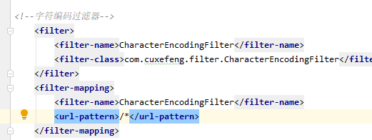

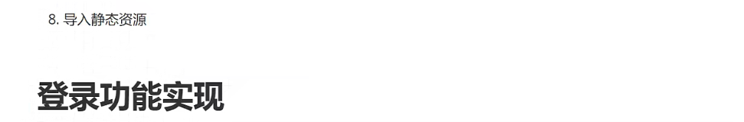

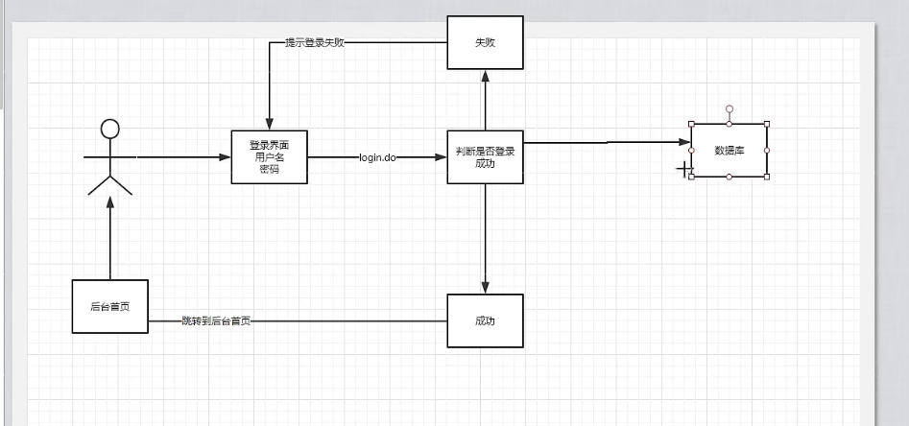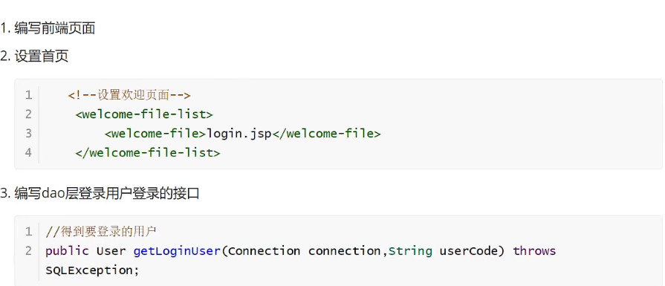**public class** UserDaoImpl **implements** UserDao{

**public** User getLoginUser(Connection connection, String userCode) **throws** SQLException {

PreparedStatement pstm=**null**;

ResultSet rs=**null**;

User user=**null**;

**if** (connection!=**null**) {

String sql = **"select * from smbms_user where userCode=?"**;

Object[] params = {userCode};

rs = BaseDao.*execute*(connection, pstm, rs, sql, params);

**if** (rs.next()) {

user = **new** User();

user.setId(rs.getInt(**"id"**));

user.setUserCode(rs.getString(**"userCode"**));

user.setUserName(rs.getString(**"userName"**));

user.setUserPassword(rs.getString(**"userPassword"**));

user.setGender(rs.getInt(**"gender"**));

user.setBirthday(rs.getDate(**"birthday"**));

user.setPhone(rs.getString(**"phone"**));

user.setAddress(rs.getString(**"address"**));

user.setUserRole(rs.getInt(**"userRole"**));

user.setCreatedBy(rs.getInt(**"createdBy"**));

user.setCreationDate(rs.getTimestamp(**"creationDate"**));

user.setModifyBy(rs.getInt(**"modifyBy"**));

user.setModifyDate(rs.getTimestamp(**"modifyDate"**));

}

BaseDao.*closeResource*(**null**, pstm, rs);

}

**return** user;

}

}

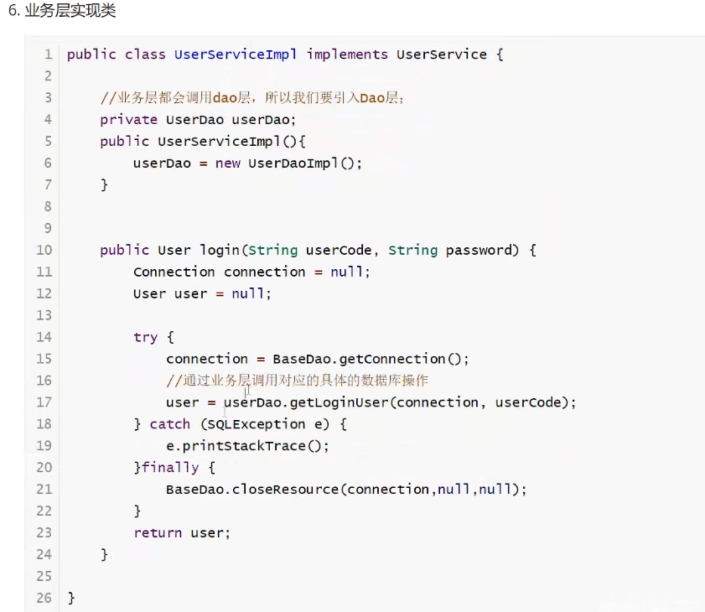**public class** UserServiceImpl **implements** UserService{

*//业务层都会调用dao层，所以我们要引入Dao层*

**private** UserDao **userDao**;

**public** UserServiceImpl(){

**userDao**=**new** UserDaoImpl();

}

**public** User login(String userCode, String passwod) {

Connection connection=**null**;

User user=**null**;

**try** {

connection= BaseDao.*getConnection*();

*//*

user= **userDao**.getLoginUser(connection,userCode);

} **catch** (SQLException e) {

e.printStackTrace();

}

**finally** {

BaseDao.*closeResource*(connection,**null**,**null**);

}

**return** user;

}



**public class** LoginServlet **extends** HttpServlet {

*//Servlet：控制层调用业务层代码*

@Override

**protected void** doGet(HttpServletRequest req, HttpServletResponse resp) **throws** ServletException, IOException {

System.***out***.printf(**"LoginServlet--start....."**);

*//获取用户名和密码*

String userCode=req.getParameter(**"userCode"**);

String userPassword=req.getParameter(**"userPassword"**);

*//调用数据库中的的密码进行对比，调用业务层；*

UserService userService=**new** UserServiceImpl();

User user=userService.login(userCode,userPassword);*//这里已经把登陆的热查出来了*

**if** (user!=**null**){*//查有此人，可以登陆*

*//将用户的消息放到Session中；*

req.getSession().setAttribute(Constants.***USER_SESSION***,user);

*//跳转到页面*

resp.sendRedirect(**"jsp/frame.jsp"**);

}**else** {*//查无此人，无法登陆*

*//转发回登陆页面，顺带提示它，用户名或者密码错误；*

req.setAttribute(**"error"**,**"用户名或者密码错误"**);

req.getRequestDispatcher(**"login.jsp"**).forward(req,resp);

}

}

@Override

**protected void** doPost(HttpServletRequest req, HttpServletResponse resp) **throws** ServletException, IOException {

doGet(req, resp);

}

}

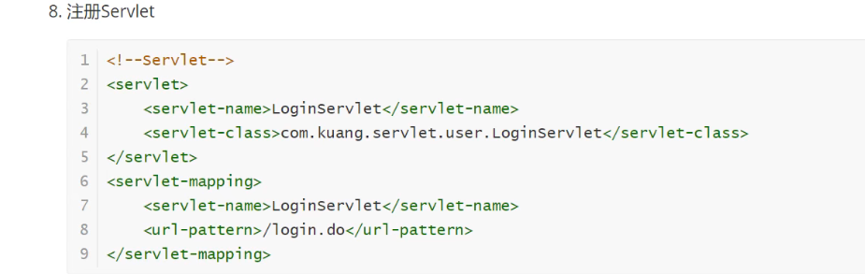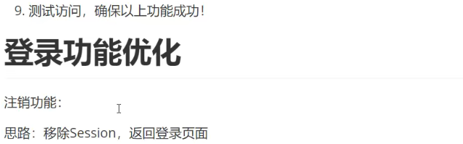**public class** LoginoutServlet **extends** HttpServlet {

@Override

**protected void** doGet(HttpServletRequest req, HttpServletResponse resp) **throws** ServletException, IOException {

*//移除用户的session（Constants.USER_SESSION）*

req.getSession().removeAttribute(Constants.***USER_SESSION***);

resp.sendRedirect(**"/login.jsp"**);*//返回登陆页面*

}

@Override

**protected void** doPost(HttpServletRequest req, HttpServletResponse resp) **throws** ServletException, IOException {

doGet(req, resp);

}

}

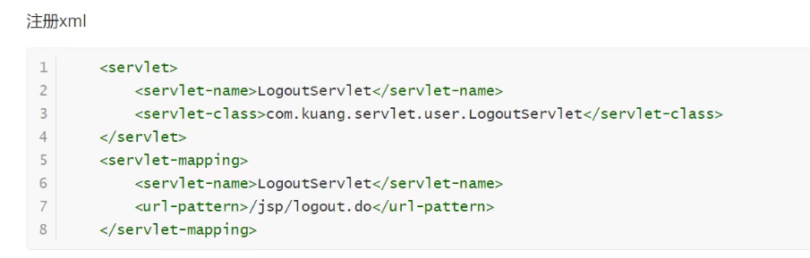

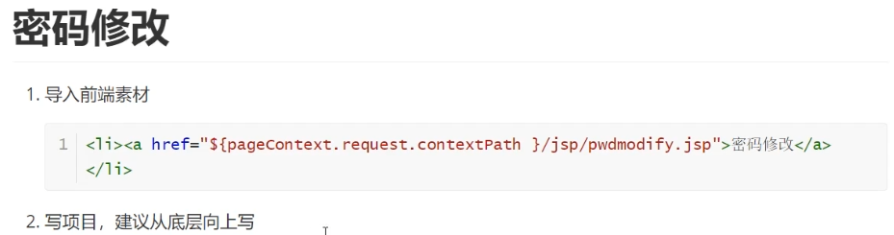

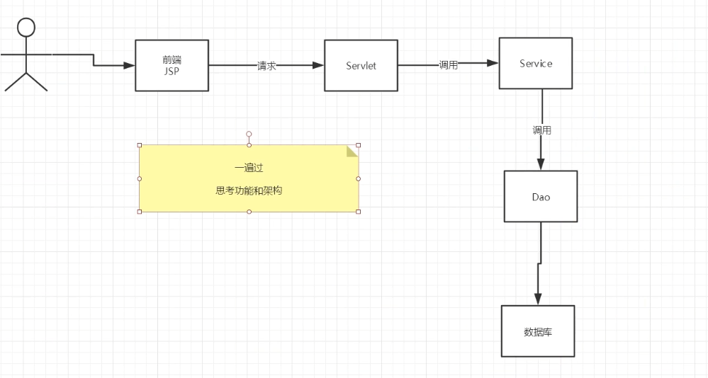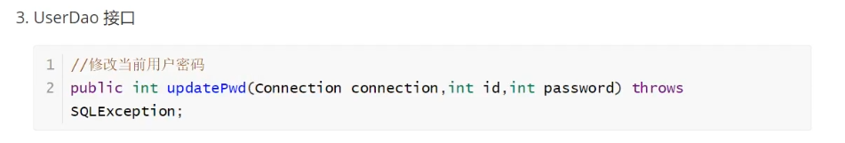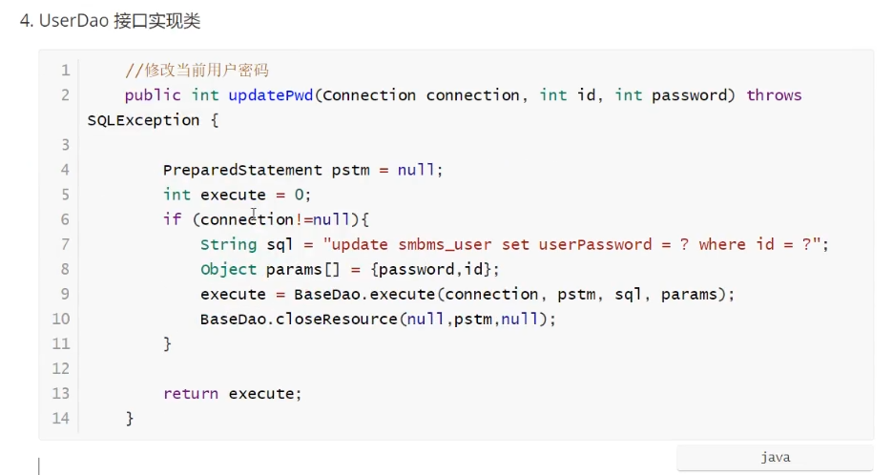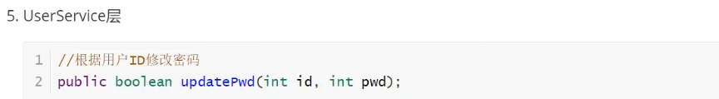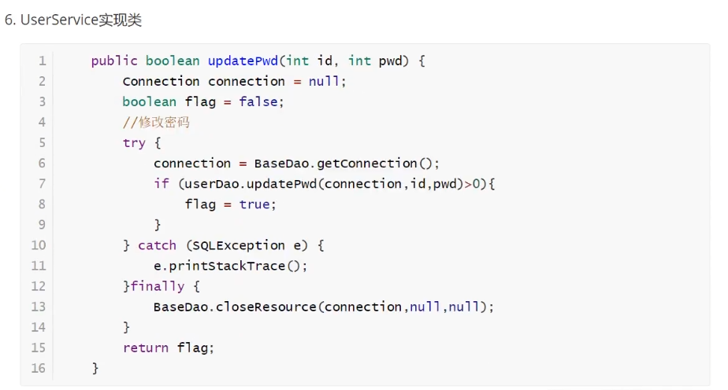**public boolean** updatePwd(**int** id, **int** pwd) {

Connection connection=**null**;

**boolean** flag=**false**;

*//修改密码*

**try** {

connection= BaseDao.*getConnection*();

**if** (**userDao**.updatePwd(connection,id,pwd)>0);

flag=**true**;

} **catch** (SQLException e) {

e.printStackTrace();

}**finally** {

BaseDao.*closeResource*(connection,**null**,**null**);

}

**return** flag;

}

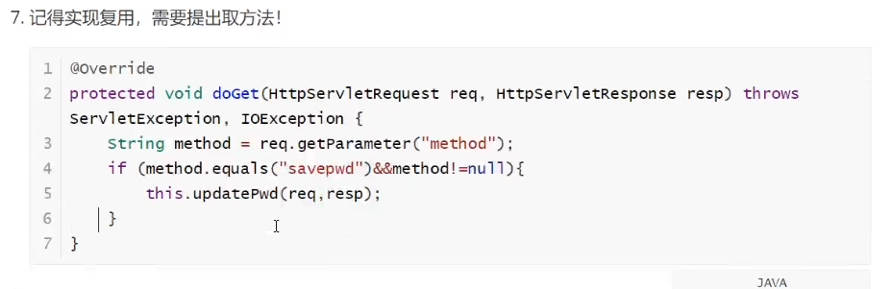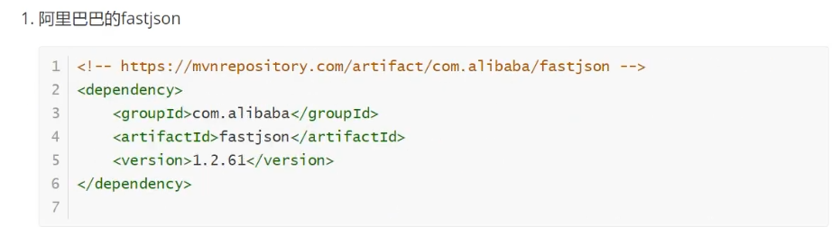

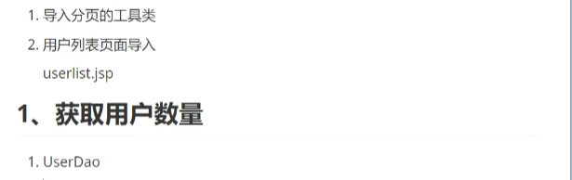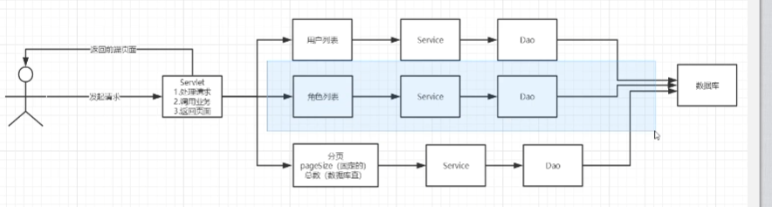

###### 文件上传和下载。

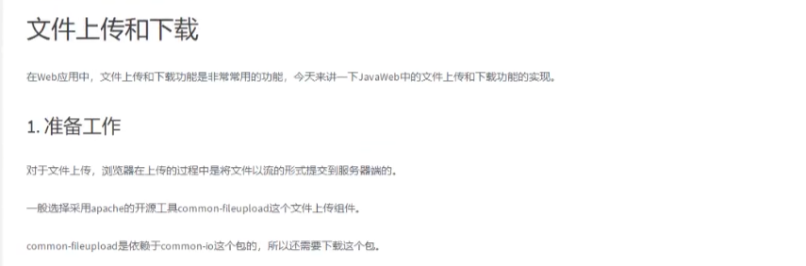

##### 

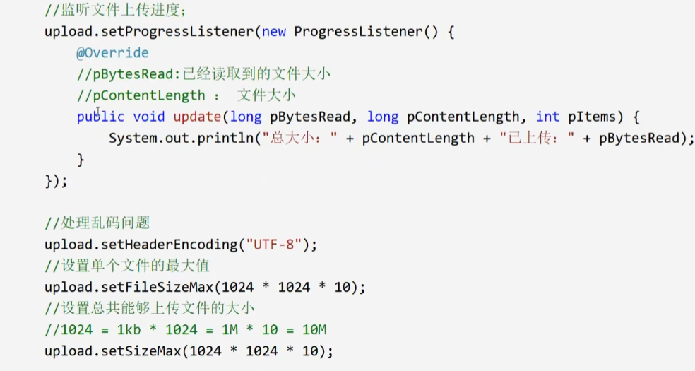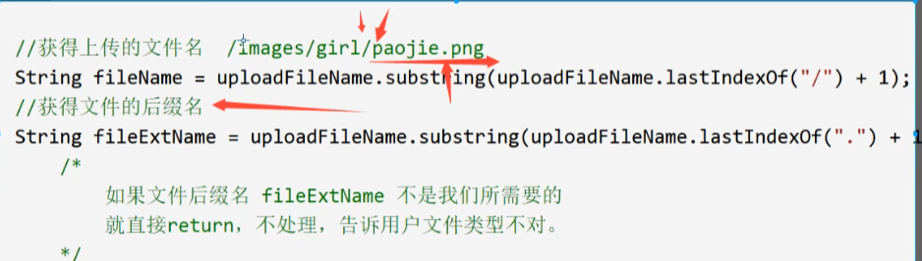

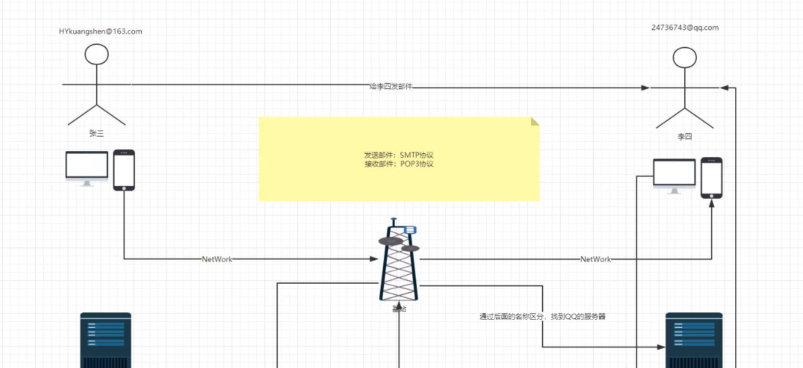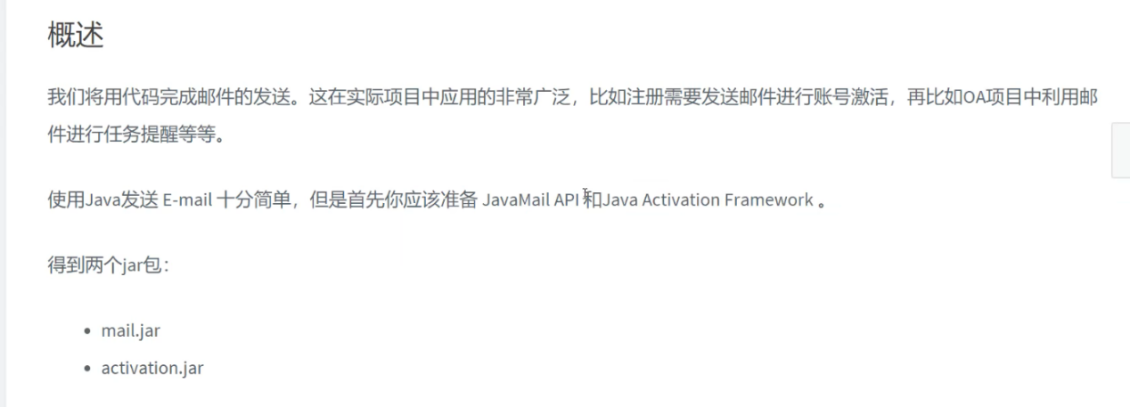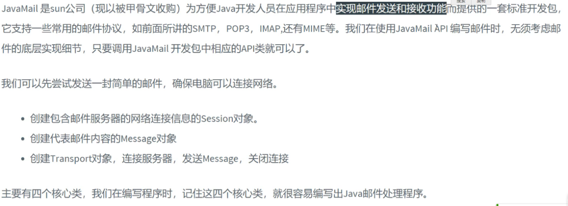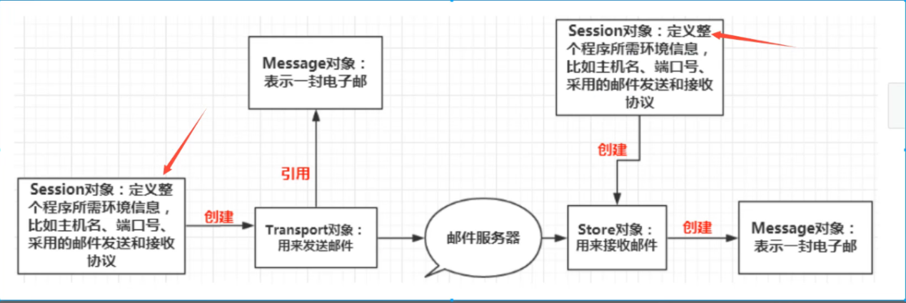

<https://mvnrepository.com/artifact/javax.activation/activation/1.1.1>

